Lesson Plan

Name: | Johnny Piper |  |  |  | Course: |  | Math |  |  |  | Grade: | 7th
Unit: | Geometric Figures
Big Idea: | Geometric figures have definite characteristics. Through silent discussion students will demonstrate their understanding of those characteristics.
Subconcept: | Parallel lines cut by a transversal have properties that help us identify angle relationships.
Literacy Strategy(s): |  | Silent Discussion
Lesson: | Chapter 10 Review |  |  |  |  |  |  | Date Taught: | February 26, 2010
Learning Objective(s): prepare students for the test by reviewing concepts of geometric figures in a format that requires more than regurgitation of facts.
Students will be able to: |  |  | demonstrate their understanding of properties of parallel lines cut by a transversal by labeling a diagram.
Idaho Standards (or National Standards if no Idaho Standards exist):
7.M.1.4. Apply concepts of size, shape, and spatial relationships.
7.M.1.4.1. Classify relationships among types of one- and two-dimensional geometric figures, using their defining properties.
7.M.1.4.3. Apply fundamental concepts, properties, and relationships among points, lines, rays, planes, and angles.
7.M.1.4.6. Use appropriate vocabulary and notations.

Detailed Description of Lesson:
For this review lesson students will, as time permits, demonstrate their understanding of:
- Parallel lines cut by a transversal
- Polygons
- Congruent/similar triangles
- Transformations
- Congruent/supplementary angles

This review is done as a game. The object is to provide as much detail as possible about the drawing on the board. Each student and the teacher is given the opportunity to write one thing about the drawing during their turn. If they are unable to begin writing within five seconds they are done for that round. Most students want to beat the teacher so they will begin to look for some of the most trivial items. The example provided here deals with the properties of parallel lines cut by a transversal.
1. Draw two parallel lines with one line crossing them.
2. Participants take turns labeling and identifying properties such as:
a. labeling the angles
b. labeling the lines
c. markings that identify lines that are parallel
d. identifying angles that are:
i. alternate
ii. exterior
iii. interior
iv. same-side
v. supplementary
vi. linear
vii. complementary
viii. acute
ix. obtuse
x. congruent
xi. and …
e. and anything else that can be identified.
Because they don’t want to lose they will remain quiet so as not to give away items that can be labeled. This could be done in a large group setting as well with the following modification.
1. Arrange students in several groups
2. Give each group a sheet of paper
3. Each group copies the figure drawn on the board
4. They pass the paper around and label it with as much information as possible
5. After 10 minutes have each group share (in turn) one thing they have written
6. If another group has the same thing no point is awarded
7. If no other group has the same label/property that group is awarded one point
8. Being quiet should not be a problem because they don’t want to give away points

Handouts:
None

Student Work:
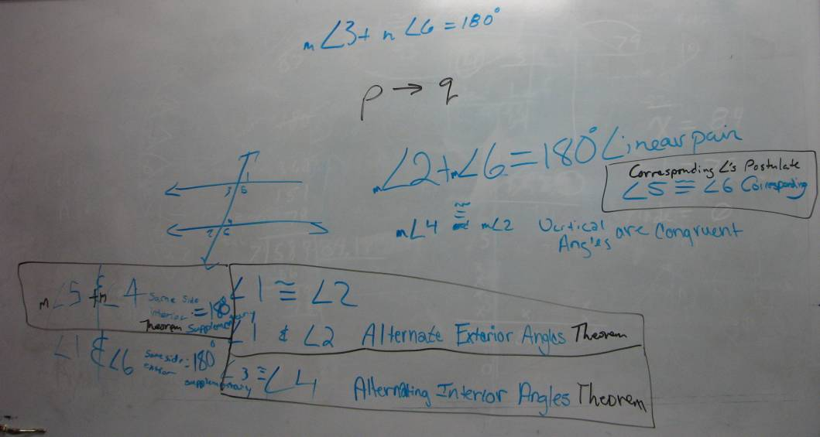
LIMSST Project Literacy Lesson Reflection Form

Name: | Johnny Piper |  | Date lesson was taught: | February 26, 2010
Lesson Title/Topic Areas: Geometric figures review

Literacy Strategies Used: Silent Discussion
Normal review activities give students more of the same to do. They are not required to demonstrate mastery because they are using the book and, in most cases, each other to get the assignment done. Using silent discussion provided the students an opportunity to demonstrate what “they” knew.

Student Response to the Lesson:
My group of 7th graders is very competitive so they don’t like giving away free points to the other students. This review activity was one of the quietest class periods ever. They were all totally engaged. You could see when their next idea was put up before their turn and then the thoughtful looks to come up with another item. Some items that were written on the board prompted new connections as can be seen in the picture in the student work section. For example if angle 3 and angle 6 are same-side-interior angles then they are also supplementary and linear and have a sum of 180º. Did the literacy strategy work? The next day was the test and three of the four students got an A and the C student got a B.

Lesson Reflection:
This review activity was so successful I will continue to use it, at least with this group. I haven’t tried to use it with my high school students. Because of the success of this activity I will be looking for other ways to make reviewing a chapter more captivating. This lesson works with algebra too as you can see in the next picture.
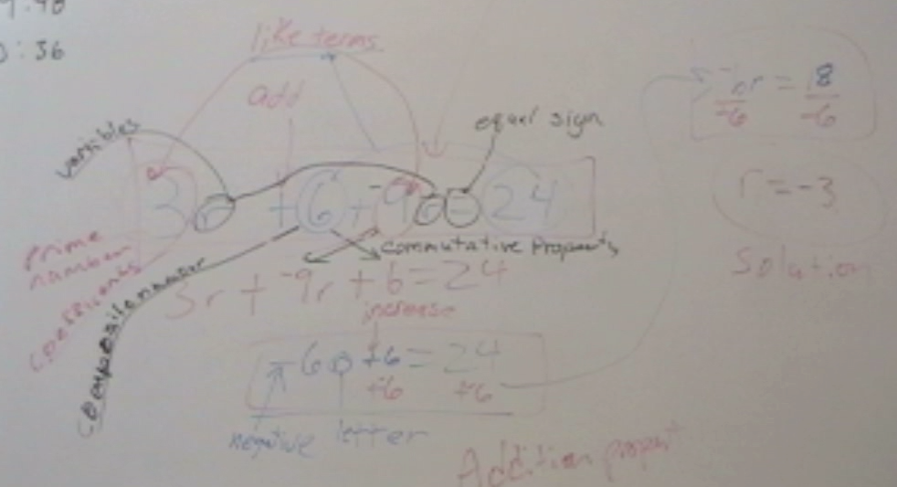
Relationship to Previous Instruction:
This was a review activity so students needed to demonstrate their understanding of the material in this chapter as well as any prerequisite knowledge that aided in comprehending the new material. When we were done the students comments were positive. “Can we do this again?” “I wish we had math all day.” “After I got out I thought of something else but didn’t say anything because I didn’t want to give anything away.” This indicated they were still engaged even after they were eliminated. Because of the success we experienced with this activity it will definitely be high on the list to do again.

