LIMSST Blank Lesson Design Template – Science Notebooks

Name: 313 Course: Life Science Grade: 7
Unit: Animal Kingdom – Earthworm Anatomy
Big Idea: All organisms of the same species have similar characteristics, even though there is variation among individual organisms.
Subconcept: Evidence can be used to accept or reject a hypothesis.
Lesson: Earthworm External Anatomy Date Taught: May 4-5, 2010
Idaho Standards (or National Standards): 7.S1.2.2 Use observations to make defendable inferences. 7.S1.3.3 Make metric measurements using appropriate tools. 7.S1.6.3 Evaluate data in order to form conclusions. 7.S1.6.4 Use evidence and critical thinking to accept or reject a hypothesis.

I N T E N D E D C U R R I C U L U M

LESSON CONTENT GOALS GUIDING QUESTIONS (displayed during Making Meaning Conference)
- Individuals of the same species will have some variation even though they might look alike at first.

- Do all the worms have the same length?
- If the worms had the same number of segments, did the worms have the same length?
- Do the longest worms always have the most segments?
- Do the shortest worms always have the fewest segments?
- What is the range of segment numbers?

I M P L E M E N T E D C U R R I C U L U M

ENGAGING SCENARIO

Think back to a few weeks ago when we were discussing the recent finding of the Giant Palouse Earthworm. We have a very different picture of that worm now, at 12” long and the past stories of 3-foot long albino worms that smell like lilies and spit at you. Scientists really want to compare specimens in the annelida phylum. Imagine what other body differences there might be. Do you think there would be similarities? Today we are going to investigate the external anatomy of an earthworm.

FOCUS QUESTION (discussed by groups, recorded in notebooks)
Guide students to “how” or “what” questions.
You may wish to start with a class chart of group focus questions.

How many segments does an earthworm have?
Does the number of segments in an earthworm species stay the same or does it vary?

Allow students to write any other question they would like to investigate about the worm.

PREDICTION/HYPOTHESIS (discussed by groups, recorded in notebooks)
Prediction: students record their predicted number of segments in an earthworm’s body.

Students make a prediction (number of segments stays the same/varies) and why.
I think that______________________________because___________________________

PLANNING
General Plan
What are things are we all going to have in common in this investigation? same species Earthworm, metric ruler,

What things are going to be different for each of us? Length of earthworm, possibly number of segments in the earthworm body

What are we going to observe or measure? Length and number of segments

Operational Plan
What will be the sequence of steps or procedures you will follow to conduct your investigation?

Have students read the handout on Earthworm Anatomy and use INSERT details
? means I don’t get it
*means important
means Oh, something I didn’t know
Discuss any ? items they may have.

DATA CHART
Before we conduct your investigation, how will you collect your data? Record length and number of segments on student sheet

What will your data collection device look like? a class chart showing number of worms, length, and number of segments

MAKING MEANING CONFERENCE (Teacher directed).

1) Making a class data chart
After completing the charts in their notebooks, the groups share their results with the class. Record the data on the board or overhead transparency discuss and analyze results. Students can add observations and other comments to their notebooks.

2) Looking for patterns from the data charts:
Teacher asks: What does this tell us? Is there a rule? Is there a pattern here? (focusing on the lesson content goals.)
Do all the worms have the same length?
If the worms had the same number of segments, did the worms have the same length?
Do the longest worms always have the most segments?
Do the shortest worms always have the fewest segments?
What is the range of segment numbers?

Teacher will guide students in writing CLAIMS AND EVIDENCE based on the data chart(s) as students share information, teacher will assist students in associating their claim with the evidence.

Help students find the maximum length along with it’s number of segments. Help students find the minimum length along with it’s number of segments. Discount any outlier data from the chart after discussion. Then help students calculate the average length and number of segments.

Once finished teacher states” Based on our claims lets REVISIT THE GUIDING QUESTIONS and discuss the answers based on our evidence.” Teacher then goes over the guiding questions and makes sure students are able to respond to them.

Examples
CLAIM EVIDENCE

Because this was our first attempt at this, I did not have students write the claims and evidence in the following suggested format. They wrote notes after we had the following discussion.

CLAIMS AND EVIDENCE Suggested format (recorded in notebook)

INSTRUCTION: Teacher says
“You are now going to write your own claims and evidence in complete sentence form. I want you to look at the focus questions and write a claim and evidence that answer these questions. Revisit the class data chart(s) to get write your claims and evidence. Record them on your notebook.

I claim that when _______________, then ____________________(happens)
I know this because I observed _____________________________________

If the claim was number of segments varied ---- Students see a variety of different segment numbers but when they observe the maximum, minimum, and average, they begin to think that those numbers don’t really vary that much. They consider individual differences like a person having a slightly different left ear size as compared to his right ear, or two students the same age having slightly different body heights, yet in the normal range for their age. They then will say that there is a normal range for the number of body segments and so the number of segments don’t vary (stay the same) and so their hypothesis is rejected based on the evidence.

If the claim was number of segments stayed the same ---- Students see a variety of different segments but realize that the variation is relatively slight and can be attributed to things like mutations, age, abundance/lack of food for weight/growth, etc. Therefore students say the hypothesis was supported by the evidence.

CONCLUSION (record in notebooks)

Students are then asked to revisit their prediction and write a sentence that states whether the evidence from their charts supported it or not. They are to explain why. They are to provide clear explanations regarding how their evidence supported their prediction.

At first I thought: _________________________________________________
Because:__________________________________________________

REF REFLECTION (record in notebooks)
Students will revisit the “Big Idea”, they may write new questions, or design new experiments.

What really surprised me about this investigation was:_______________________
________________________________________________________________________

But now I wonder:__________________________________________________

Handouts used with this unit:
- Earthworm Anatomy Length Hypothesis Lab
- Earthworm Anatomy Dissection Lab
- Invertebrate Phylum Tree Note-taking Sheet for students to record information presented by their fellow classmates. Used with posters presented after students did individual 4-square note-taking sheet on their phylum and then grouped together to create a group phylum poster.

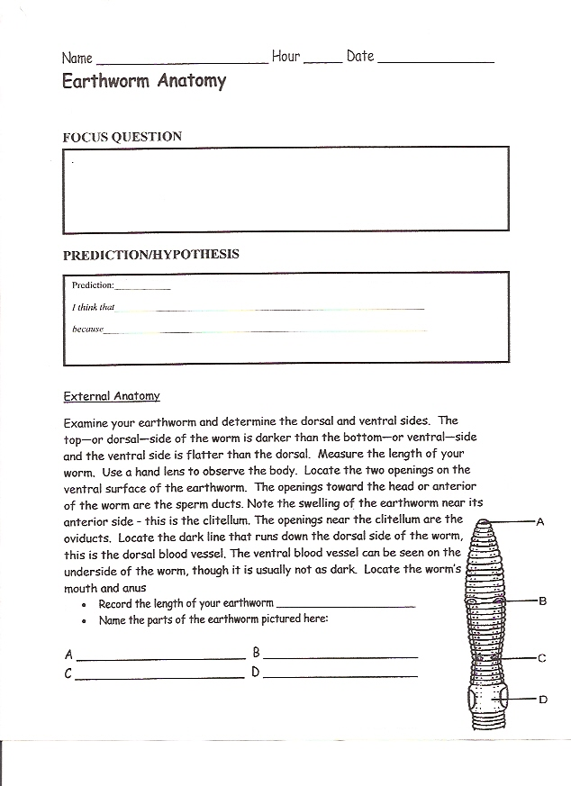
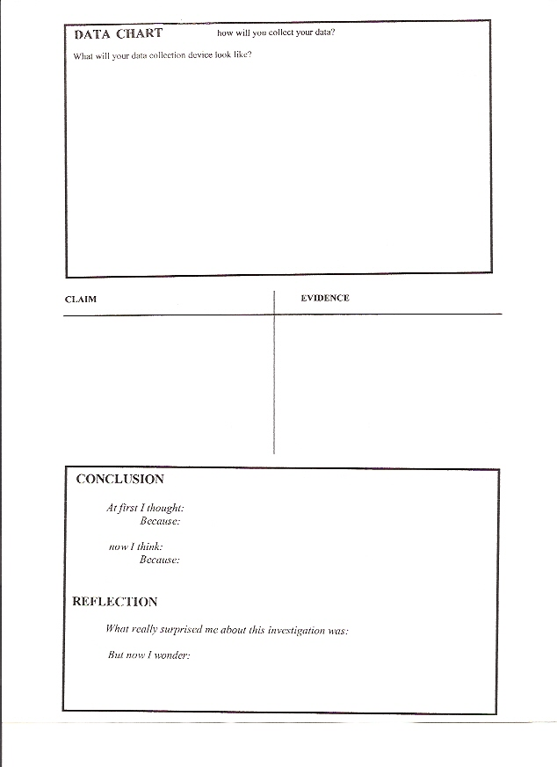
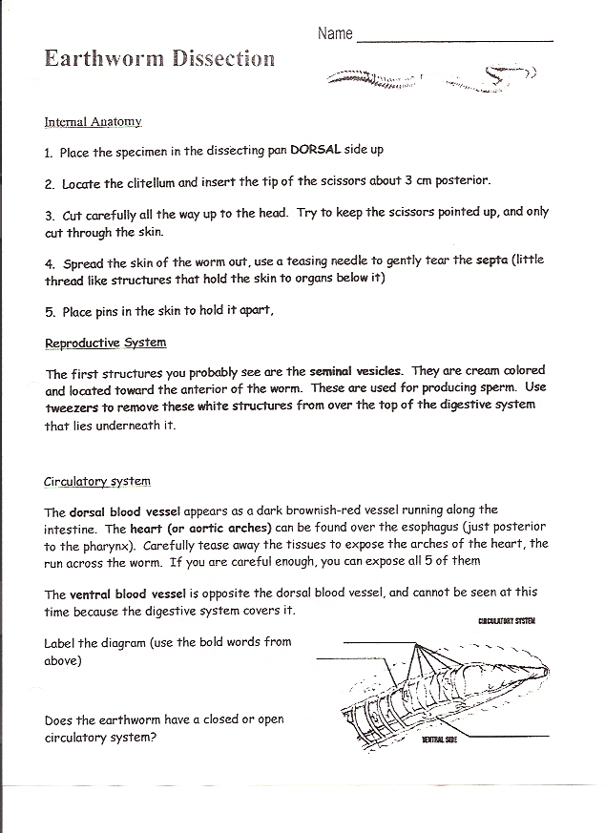
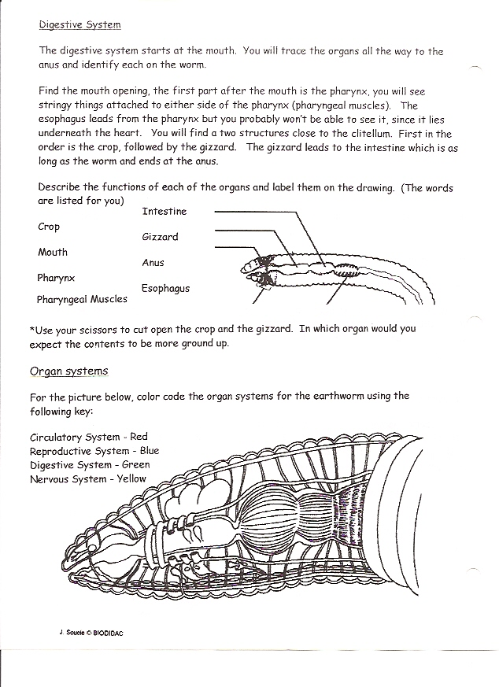
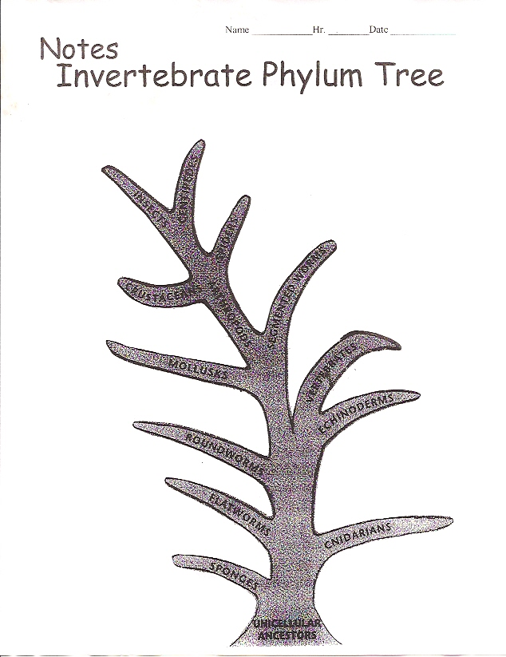

LIMSST Project Literacy Lesson Reflection Form

Name: | 313 |  | Date lesson was taught: | May 4-5, 2010
Lesson Title/Topic Areas:
Earthworm Anatomy – Animal Unit

Literacy Strategies Used:
(Please discuss what literacy strategies you embedded in this lesson. What were your goals in using these strategies? Be specific and use as much detail as possible.)

I used the INSERT strategy during the students’ reading of their handout. We did a lot of discussion and writing what they thought after the discussion. My goal in using these strategies was to have more engagement in critical thinking and the scientific method rather than just use the anatomy activity for learning form and function in living things.

Student Response to the Lesson:
(Was the strategy effective? Were students able to read/write as needed in this lesson? What attitudes were displayed? How did specific
students and/or the class do? How did the literacy strategy aid in developing student understanding of the topic? Cite specific evidence from the samples of student work)

I feel the strategy was effective because all the students were engaged in the lesson. From their writing I felt most of the students realized that organisms are not exactly alike, but have a normal range of differences. (Studnts used the words ballpark, still around the same, and still close to explain why they thought the number of segments stayed the same.) Some refused to acknowledge anything more than the literal meaning of variation.

Lesson Reflection:
(What worked well with this lesson? What challenges did you encounter in this lesson? Would you change certain aspects of the lesson or the questions that you asked? How does this influence future lesson planning?)

I am very pleased with the student engagement and the critical thinking that students did. But overall I think the lesson worked only fair. It was time consuming because many of my students could not use a calculator accurately and many have a difficult time writing quickly and they couldn’t think and do writing fast enough to keep up with everything that was going on. I liked how the lesson was laid out, but think that I need to work on scaffolding my lessons more. They needed more practice in working with fairly large amounts of data. They can find an average but kept getting lost punching in the wrong numbers. Finally by the last class of the day, I figured out to have them work in pairs with one reading the data quietly while the other plugged in the numbers on the calculator. I tried to keep the concept on animal characteristics simple in order to concentrate on the underlying concept of using the scientific method, but they were so excited about the worms that they had trouble focusing in on the steps to the scientific method, that we had practiced earlier. I feel we need to do more practice in a lab type setting for them to be able to comfortably concentrate on everything.

Relationship to Previous Instruction:
(Have you taught this lesson/topic prior to the LIMSST project? If so, how did your teaching of this lesson differ from what you taught before? How did students’ reactions to this lesson differ?)

I had dissected worms with students before, but had not incorporated an experimental part, it was more of a demonstration with students mimicking the actions demonstrated. I like the feel of this lesson this year, that students actually learned more about the earthworm, but I will need to do a lot of little data collections and more claims and evidence before we tackle the earthworm external anatomy lesson so that it doesn’t take us as much time as this year’s did.

