**Lesson Plan Template**

**Name: _204______ Course: Math 8________ Grade: _____8_____**

**Unit: _”Packaging Unit”______**

|  |  |
| --- | --- |
| **Big Idea:** | Relating the measures of length and width to the perimeter and area of the surface area of a prism. |

**Subconcept: _1._Relationship of length and width to perimeter and area**

**Literacy Strategy(s): _Frayer Model**

**Lesson: _Perimeter and Area Date Taught: October 10, 13,2008___**

**Learning Objective(s):**

* Students will be able to ___measure to the nearest millimeter___
* Students will be able to interpet perimeter as the number of units that measures the distance around
* **Idaho Standards (or National Standards if no Idaho Standards exist):** 
  + **8.M.2.1.1 Select and use appropriate units and tools to make formal measurements.**
* **Use two-dimensional representations of three-dimensional objects to visualize and solve problems such as those involving surface area and volume. NCTM Standards**

**Detailed Description of Lesson:**

Describe the sequence of activities in the lesson. Include the instructions that students are given for activities. Remember that these lessons will be shared with other teachers. Please provide enough detail so that other teachers could replicate the lesson.

**Day 1**

Lab measuring objects:

* Short instruction on using a centimeter ruler and demonstration on measuring length and width.
* 6 stations of rectangular objects (ie. Chess board)
* Students must calculate the length and width of each object then calculate the perimeter and area of each object.

**Day 2**

Review with partner the calculations.

Complete Frayer Model

**Handouts:**

Include any handouts that students were given.

LESSON 1.wkst1 LIMSST.KD

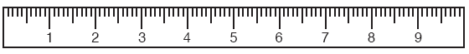

Use the assignment whiteboard.

Length =

Width =

Perimeter =

Area =

Length =

Width =

Height =

Volume =

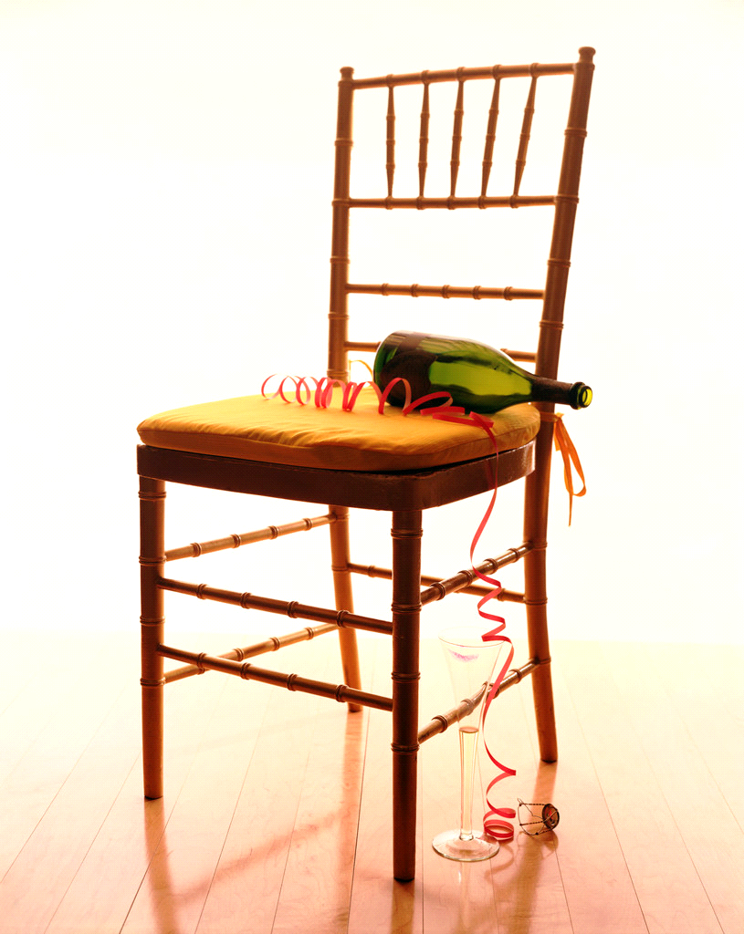

Chair seat

Length =

Width =

Perimeter =

Length =

Width =

Height =

Volume =

Pie Box



Classroom door

Length =

Width =

Perimeter =



Length =

Width =

Perimeter =

Area =

Lesson 1.wkst2 LIMSST.KD

**Formulas**

Perimeter…**Distance Around**…add the measures of all the sides together

Area … **covers**…length x width

Volume…**Fills**…length x width x height

**LIMSST Project Literacy Reflection Form**

**Name: _204____ Date lesson was taught: _October 10 - 18__**

**Lesson Title/Topic Areas:**

Formulas for perimeter, area and a little bit on volume and surface area.

**Literacy Strategies Used:**

(Please discuss what literacy strategies you embedded in this lesson. What were your goals in using these strategies?)

Frayer model

Classroom discussion

Teamwork on lab

Questions

**Student Response to the Lesson:**

(Was the strategy effective? Were students able to read/write as needed in this lesson? What attitudes were displayed? How did specific

students and/or the class do? How did the literacy strategy aid in developing student understanding of the topic? Cite specific evidence from the samples of student work)

The students enjoyed the lab the most but I forgot to save some of their work. They do not like to read or write independently and kept asking for help on what to write for the Frayer Definition. The first example above was the best. Most of the work was worse than the second example and many of the students just refused to complete the assignment.

**Lesson Reflection:**

(What worked well with this lesson? What challenges did you encounter in this lesson? Would you change certain aspects of the lesson or the questions that you asked? How does this influence future lesson planning?)

The lab was the most interesting for the students. They enjoyed moving around and worked well independently. Given a calculator and minimal instruction, they were able to measure and compute the length and width, etc. with accuracy.

**Relationship to Previous Instruction:**

(Have you taught this lesson/topic prior to the LIMSST project? If so, how did your teaching of this lesson differ from what you taught before? How did students’ reactions to this lesson differ?)

I have taught this unit and lesson before and not met with the resistance to writing and independent thinking that I did this year. This is a basic class with pretty severe emotional and behavioral needs. I could not figure out how to deal with the students who were absent so assigned worksheets.