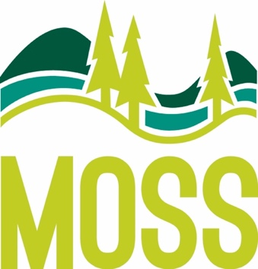 | McCall Outdoor Science School  1800 University Lane  PO Box 1025  McCall, ID 83638  (888) 634.3918 office  (208) 634.5244 fax  www.uidaho.edu/moss
Item | Before Tax | After Tax (7%)
Sticker | $1.40 | $1.50
Sunglasses | $4.67 | $5.00
Ceramic Mug | $12.15 | $13.00
Travel Mug | $12.15 | $13.00
Water Bottle | $12.15 | $13.00
Trucker Hat | $12.62 | $13.50
T-Shirt | $14.95 | $16.00
Beanie | $22.90 | $24.50
Hoodie | $29.91 | $32.00

Prices are subject to change.
All items may not be in stock at the time of your program.
We accept cash & checks. No credit cards – be sure to tell chaperones ahead of time!
Checks payable to Bursar, University of Idaho.

