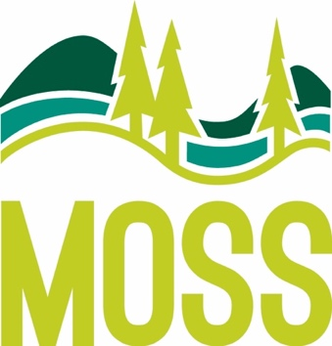 | McCall Outdoor Science School  1800 University Lane  PO Box 1025  McCall, ID 83638  (888) 634.3918 office  (208) 634.5244 fax  www.uidaho.edu/moss

TASK TIMELINE
MOSS Website: http://www.uidaho.edu/cnr/mccall-outdoor-science-school/programs-and-services/k-12/school-residential-programs
14-9 months | - Receive confirmation letter  - Pay the deposit within 14 days
6-3 months | - Receive the paperwork email  - Check out your school folder – shared in paperwork email  - Complete the Pre-Program Questionnaire (PPQ) - in your school folder  - Read about our Education Philosophy - in your school folder  - Read the Curriculum Overview – in your school folder
4-1 months | - Enroll students, chaperones & teachers =  https://moss.uidaho.edu  Password: learning  Program Type: School Residential  - Background check teachers & chaperones  - Share chaperone tips – found on the website  - Share teacher tips – found on the website  - Share the What to Bring info – found on the website
7-4 weeks | - Add field group and sleeping group information to your logistics sheet – in your school folder  - Complete the School Agreement Form – in your school folder  - Connect with Food Systems & Sustainability Manager, Megan, mfaulkner@uidaho.edu, about food allergies (including severity), preferences & intolerances.  - Check out Adventure Learning and share the link with students and parents
3-2 weeks | - MOSS will cross reference enrollment to logistics & ask follow-up questions  - Coordinate pre-arrival phone call with your Program Coordinator (Beth or Leslie)  - Fill in the PPQ gaps  - Remind participants of the teacher/chaperone tips and the what to bring list  - Share the MOSS Store info – in your school folder
0 days | - 1p arrival @ MOSS!
4 or 5 days | - 10a departure from MOSS
14 days | - Payment in full is due

