Homework 2

Climate Change Ecology, Spring 2017

Due Wednesday, February 22, 2017

Your name: ___________________________________________________

Please answer the following questions in a different font (**like this**) to help me find your answers. You may work in a group (except where noted below), but your answers and your words must be your own.

Please email me a copy of this file by midnight of the due date.

**Climatic water deficit**

Use the Excel spreadsheet “CWDcalculator_moscow_id.xlsx” to answer the below questions. Some guidelines: a) Yellow cells are the only ones you need to change (if at all). b) The “Control” worksheet (tabs at bottom) considers the current climate; the “Scenario” worksheet is where you can change the climate. c) Many of the columns and rows are for calculation and don’t need to be inspected; see “Variable Descriptions” worksheet. d) “Daylength” worksheet is for calculation only (do not change). e) The second year is the year you should pay attention to because the calculation of soil moisture is better then.

***A. Current climate in Moscow, ID***

Given the current climate in Moscow, ID (the spreadsheet without you making any changes), inspect the cells in the “Control” worksheet and the graphs to answer the following:

1. When (what month) is the peak of water supply? (2 points)

2. When (what months) is climatic water deficit greater than 0? (2 points)

3. Which variable corresponds to plant growth? When is the growing season? (2 points)

4. For which growing season month(s) is there no deficit (CWD=0)? (2 points)

5. Explain why CWD occurs when it does by invoking water supply, PET, and AET. (2 points)

6. Sum the annual CWD in the second year by either a) highlighting the appropriate cells and noting the “Sum” at the bottom of the window or b) in another cell, adding a “Sum” function of these cells. Do the same for AET. What are these values (units are mm)? (2 points)

7. Use the Stephenson (1990) figure below. What plant formation corresponds to your summed AET and CWD from the previous question? Does this seem about right given what you know about Moscow? (2 points)

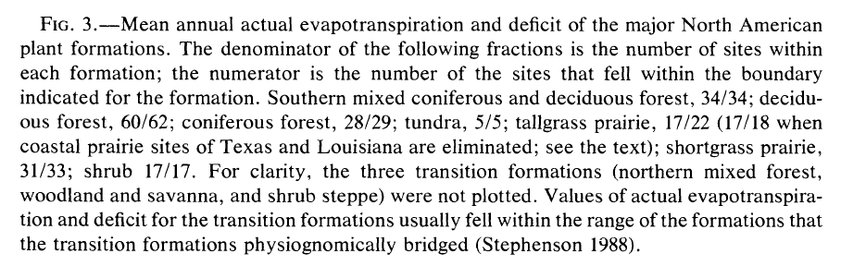

***B. Climate change in Moscow, ID***

Assess how climate change will influence the water balance terms by changing values in the “Scenario” tab. For each of the scenarios below:

* copy and paste the new graph below,
* describe important changes in the graphs,
* list what the summed AET and CWD values are and differences with the control scenario,
* describe what changes in the expected plant formations are, if any,

Excel hint: use a formula like “=Control!B2+3” for Scenario!B2, then drag the small square in the lower right corner of the highlighted cell to C2, then drag small square of highlighted B2 and C2 to B13 and C13. This is a quick way of apply the same formula to a set of cells.

8. Scenario 1: year-round warming (both MAXT and MINT of all months) of 3 deg C. (5 points)

9. Scenario 2: change in precipitation only based on expected changes in the Pacific Northwest: a 5% increase in all months except June/July/August, which will have an 8% decrease. (5 points)

10. Which effect is strongest of the two Scenarios? (2 points)

11. For the greater change in CWD from the two above questions, describe how the change in CWD might affect plant formations from above Stephenson figure. (2 points)

***C. Climate change in the Western US***

The Western Governors’ Association wants your help in estimating changes in natural resources given future climate change. Calculate the water deficit and estimated plant formation for a climate station of your own choosing in a much different place in the western US that represents a different vegetation type. Ensure you have a different one from your classmates by not working together.

12. Pick a station from http://www.wrcc.dri.edu/climatedata/climsum. Fill in the appropriate latitude. What station did you pick? What is its latitude? Take a screenshot of the monthly mean climate variables and paste it below. Use Google maps to estimate the dominant plant formation (i.e., based on satellite imagery). (3 points)

13. Copy the monthly means of MAXT, MINT, and precipitation into a separate copy of the CWD calculator spreadsheet. Copy the resulting water balance graph from the spreadsheet to below. What is the expected plant formation based on AET, CWD, and the Stephenson figure using current climate? (5 points)

14. Estimate the future climate at your location using maps from the 2014 National Climate Assessment: http://nca2014.globalchange.gov/highlights/report-findings/future-climate#intro-section-2. For “Projected Temperature Change”, selected the “Higher Emissions (A2)” scenario. Estimate the annual temperature change in the last decades of the 2100s at your chosen location. Repeat for the seasonal precipitation values (changes in percentages). Write down the five values here. (2 points)

15. Copy the current climate to the “Scenario” worksheet, then add in the above changes. How does annual AET and CWD change following this expected climate change? Take a screenshot of the monthly mean climate variables and paste it below. Copy the resulting graph below. How does future climate change modify CWD? How might the changes in climate affect the types of plants that can exist at this location? (5 points)