Homework 3
GEOG 430, Climate Change Ecology, Spring 2017
Due Friday, March 10, 2017 (midnight)

Your name: ___________________________________________________

Please answer the following questions in a different font (like this) to help me find your answers. Email me a copy of your homework. You may work in a group, but your answers and your words must be your own.

I. Phenology

1. Why are phenological studies some of the best for establishing the impacts of climate change on biology? (3 points)

2. What are three important messages of Table 4.1 in the Hannah textbook? (3 points)

3. Growing degree days.

A. Use the “moscow_daily_tmin_tmax_2012.csv” file from the course web site. This CSV file gives the date, maximum temperature, and minimum temperature for the Moscow weather station in 2012.

a. Write the equation for growing degree days using a formula with variables; define each variable and note its units. (3 points)

b. Calculate the growing degree day (GDD) amount above a baseline of 10ºC for each day. First compute the average daily temperature, and use this in your GDD calculation. Then use the IF formula that looks something like this (read syntax/help on IF): “=IF(D2 > 10,D2-10,0)”. What is the minimum of the daily GDD? Maximum? (3 points)

c. Calculate the cumulative growing degree days (since January 1) for each day in the entire time series. Use a formula that sums the current and previous cells (except for the first cell). [HINT: After creating a formula in a cell, double click the little square in the corner of the selected cell to extend that formula to the end of the same column (all rows).] When did lilacs bloom (which bloom after 100 GDD)? (3 points)

d. Assume a climate change scenario of 2ºC in 2100 (applied evenly throughout the year) and redo your calculations. When will lilacs bloom then? What is the time difference (how many days earlier)? (3 points)

e. Include a screenshot of the first few lines of your Excel file that illustrate all the calculations above. (3 points)

B. How is one year’s phenology different than average? Using “moscow_daily_tmin_tmax_2015.csv”, which includes the first several weeks of 2015, and “moscow_daily_tmax_tmin_mean19712000.csv”, which is the 30-year mean temperature record, compute the GDD for a baseline of 4.4 deg C.

f. What are the cumulative GDD values for February 19 in 2015 and for the 1971-2000 average? (3 points)

g. For the 1971-2000 average year, when does GDD equal or exceed the value for February 19, 2015? (3 points)

h. Include a screenshot of the first few lines of your Excel file that illustrate all the calculations above. (3 points)

4. There are three reasons why climate change may lead to phenological timing mismatches of species and resources and/or between species. For each (below), describe a documented case. CITE YOUR SOURCES!!! (9 points)

a. different T sensitivity among species

b. different cues for phenology (i.e., not temperature) at one location

c. cues from other regions

II. Ecosystems and habitats

5. What is the difference between “ecosystem structure” and “ecosystem function” (define each)? Describe one published example of how climate change is affecting each. CITE YOUR SOURCES!!! (6 points)

6. Explain what the below figure says about climate change and treeline shifts. (5 points)

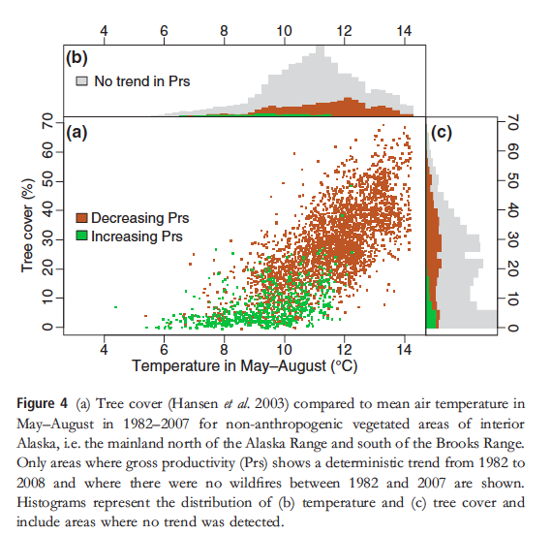

III. Public acceptance of climate change

7. The impacts of climate change on plants, animals, and ecosystems is an excellent means for getting people connected to this issue. What is an example of a local impact to plants, animals, and/or ecosystems (NOTE: not physical climate variables) that may resonate with people in the following locations? Describe the situation and how it is affected by climate. CITE YOUR SOURCES!!! (10 points)

a. Northern Idaho

b. Southern California

c. Florida

d. Alaska

e. New York City

