Lesson Plan Template

Name: |  | 208 |  |  |  | Course: |  | 7th Math |  |  |  | Grade: | 7th
Unit: |  | Fractions and Integers
Big Idea: |  | Fractions can be used to represent a portion of a whole. Operations used with whole numbers can be applied to fractions and integers.
Subconcept: |  | To add or subtract fractions with common denominators, add the numerators
Literacy Strategy(s): |  |  | Students record by writing their solutions and present their work at the board to class for discussion.
Lesson: |  | Add/subtract fractions |  |  |  |  |  |  | Date Taught: | 11-16/17-09
Learning Objective(s):
 | Students will be able to |  |  | demonstrate addition and subtraction of fractions using Cuisenaire rods.
 | Students will be able to |  |  | present solutions to the class using correct vocabulary regarding fractions (numerator, denominator, etc.).
Idaho Standards (or National Standards if no Idaho Standards exist):
7.M.1.2.2 Add, subtract, multiply, and divide whole numbers, fractions and decimals; and add, multiply, and divide integers. (327.02.a, 327.02.d)
7.M.1.2.7 Use appropriate vocabulary and notations. (327.02.f)

Detailed Description of Lesson:
Add/Subtract Fractions with common denominators

Cuisenaire rods will be used as a physical representation of operations involving fractions. After the model has been created students will record their results. After results are recorded they will share their findings with the class.

Day 1
Introduce students to Cuisenaire rods and show them how they can be used to represent fractions. Show them the examples using the actual rods represented on the handout. Using the handout they should record the color blocks they used to create each fraction and their position of the blocks. Use the first and second pages of the included handout for the first days activities.

Day 2
When they are familiar with using the rods to represent fractions move them to adding fractions.

Begin with simple fractions. Represent them as they are written with a smaller colored block (the numerator) on top of a larger colored block (the denominator). To show addition of fractions with common denominators line up the fractions so that denominator blocks are side by side. To find the result add the values of the two numerator blocks.

Example:
1/5 + 2/5 can be shown by placing two yellow (5) blocks next to each other and putting a white (1) block on top of one and a red (2) block on top of the other. Adding one and two we get three for the numerator. The answer then is three-fifths. This can be emphasized by moving the white block next to the red block on one of the yellow blocks and putting a light green (3) block on the other yellow block to show three-fifths.

A handout can be generated at http://www.homeschoolmath.net/worksheets/fraction.php
Examples are included on the third and fourth pages of the handouts. The third page has only common denominators. The fourth page has unlike denominators to be used in another lesson. Make sure to select fractions with like denominators and set other parameters to meet your students needs. There is a box at the bottom to write instructions you would have them follow.

LIMSST Project Literacy Lesson Reflection Form

Name: | 208 |  | Date lesson was taught: | 11-16/17-09
Lesson Title/Topic Areas:
Add/subtract fractions

Literacy Strategies Used:
- Students had to record the results of the Cuisenaire rod exploration by describing the rods used to represent fraction.
a) Goal: (Writing strategy) Students were to write about the concrete model used to represent a numerical value (fraction).
- When addition and subtraction were involved they explained how they used the rods to find the result of one problem they solved.
a) Goal: (Writing/Verbal strategy) Students wrote and explained verbally their solutions to addition and/or subtraction problems involving fractions. The focus was on key terms such as numerator, denominator, common denominator, etc.)
- Students displayed their work on the board by replicating the work they had done on their paper. Another student was called upon to explain the work to the class.
a) Goal: (Verbal strategy) Students were able to present another students work to the class based on the work displayed on the board.

Student Response to the Lesson:

Students like “playing” with anything that is manipulative. These guys were no different. They made several designs, but when we got to the lesson they worked. It did not take them long to understand how to represent a fraction using the Cuisenaire rods. They were able to make and record several examples. These can be seen in student samples marked in the upper right corner with a number followed by the letter “a”. The activity learning to represent fractions took one period.

The lesson on the following day involved using Cuisenaire rods to show addition or subtraction of fractions. Because the groundwork had been laid the previous day, students were able to begin right away. They recorded the process for one of the problems they solved. Toward the end of the period most of the students did not use the rods because they had figured out how to add fractions with common denominators.

Once the concept of adding only numerators of fractions with common denominators was understood they wanted to quit using the rods and just do the math. When a tool has served its purpose it is generally set aside so I let them work without the rods. When fractions with unlike denominators were introduced in a different lesson we did use them again to find common denominators. Once they understood what was happening, could explain it, and demonstrate a proper solution they were allowed to put the rods aside until they needed them. One student who was struggling with regular written work was able to finish his assignment at a later date faster and more accurately then the other students. When he was done we compared answers. After we finished he went to other students to help them.

Lesson Reflection:
This was the best lesson I have taught when I introduced fractions and operations involving them. Students developed a better understanding by representing fractions with the Cuisenaire rods, writing about them, and then explaining their work. We also cut up unit fraction strips to work with in other lessons. Between the two visual aids students appeared to grasp concepts involved in fraction addition and subtraction. One thing I may change is to make a game of it to get greater buy-in to use the Cuisenaire rods. Of course a game would require prizes. Candy would work well.

Relationship to Previous Instruction:
Teaching fractions year was different owing to both the LIMSST project and the Idaho Math Initiative. The LIMSST project brought in the literacy (writing and verbal) strategies that would otherwise be missing. Writing seems to provide another link to learning and help students remember lessons taught. Explaining their writing helps them struggle with the vocabulary of the discipline. Both writing and speaking give insight into student thinking.
Handouts:
Worksheets generated at http://www.homeschoolmath.net/worksheets/fraction-b.php will be used by students to demonstrate proficiency with Cuisenaire rods when adding or subtracting fractions.

Learn Fractions and Fraction Addition
with Cuisenaire Rods

Using Cuisenaire Rods to name a Fraction

The standard method of showing fractions with the Cuisenaire Rods is to place one rod over the other to compare their size. The rods can be shown vertically or horizontally (as shown below).

For Example:
Arrange your rods to represent 1/2 and 3/4 using the purple rod as the denominator. In order to represent 1/2 using the purple rod as the denominator we must first express the fraction in equivalent terms. Since 2 red rods in a train equals 4 cm. we must multiply the numerator and denominator by 2 red rods.
Take the numerator 1 * 2 red rods = 2
Take the denominator 2 * 2 red rods = 4
So representing 1/2 using the purple rod as the denominator equals 2/4 as shown below.
2/4 =
One red on top of one purple shows two-fourths equivalent to one-half.

Now, in order to represent 3/4 using the purple rod as the denominator. Since 1 purple rod equals 4 cm. we must multiply the numerator and denominator times 1 purple rod.
Take the numerator 3 * 1 purple rod = 3
Take the denominator 4 * 1 purple rod = 4
So representing 3/4 using the purple rod as the denominator equals 3/4 as shown below.

3/4 =

One green on top of one purple shows three-fourths
Now it's your turn:
A. Arrange your rods to represent each of the following fractions using the dark green rod as the denominator. Record your answer under the fraction.
For Example: 1/6 =
So we would record; one white on top of one green shows one-sixth.

1. 1/2 2. 2/3

3. 5/6 4. 2/6

B. Arrange your rods to represent each of the following fractions using the brown rod as the denominator.
For Example: 4/8 =
One purple on top of one brown shows four-eighths equivalent to one-half.
5. 3/4 6. 3/8

7. 2/8 8. 5/8

C. Now for a real challenge! Let's say the orange and red rod are taped together as the unit. We'll call this color rorange. Represent each of the following fractions using the rorange rod as the denominator, then record your results below the fraction.
For Example: 7/12 =

9. 1/2 10. 1/3

11. 1/4 12. 5/6
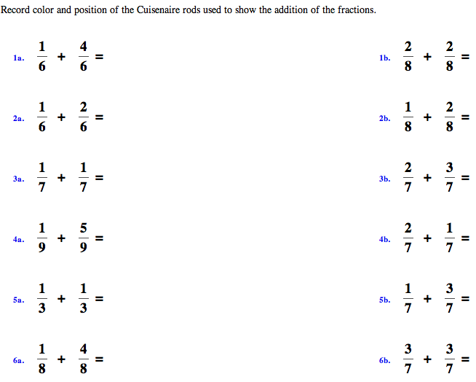
Illustrate and solve each of the following using Cuisenaire rods.

1. 1/2 + 1/4 = 2. 1/3 + 3/4 =

3. 3/4 + 5/8 = 4. 3/4 - 3/8 =

5. 2/3 - 1/6 + 3/4 =

Student Work:
See pdf files labeld with a number and letter in the upper right corner.
Showing your work for converting improper fractions to mixed numbers

Review:

Use fraction strips to represent the improper fraction.
Example: 15/4 would look like this

Decompose an improper fraction by writing an addition problem using fractions that have the same denominator and are equivalent to one. Make sure the sum of the numerators equals the original numerator.

Example:

15/4 = 4/4 + 4/4 + 4/4 + ¾ = 1 + 1 + 1 + ¾ = 3 ¾
When you have completed your work on paper raise your hand so the teacher can check your work. After the teacher has checked you work you can put it on the board to share with the class.

- Student 1
- Student 2
- Student 3
- Student 4

Record the problem here:_________________________________________________________________________

Show the solution using fraction strips here
Show the solution by decomposing the fraction using fractions equivalent to one here

Record the process. Choose one of your solutions and explain the process you used to solve your problem.

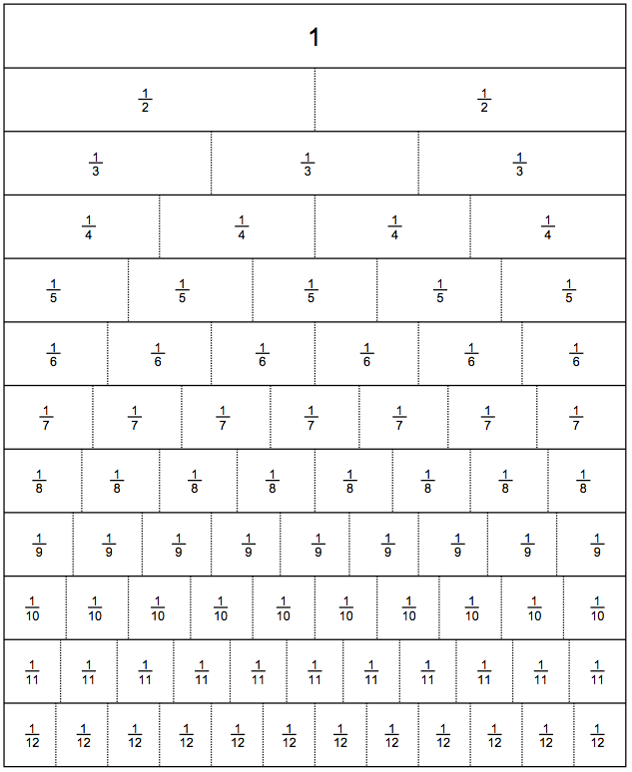
http://lrt.ednet.ns.ca/PD/BLM/pdf_files/fraction_strips/fs_to_twelfths_labelled.pdf
http://lrt.ednet.ns.ca/PD/BLM/table_of_contents.htm

