Lesson Plan

Name: | 208 |  |  |  | Course: |  | Math |  |  |  | Grade: | 7th
Unit: | Measurement and Area
Big Idea: | This unit of study students will review previous knowledge about square roots which will lead into the Pythagorean theorem. They will also learn to apply the area formulas for parallelograms, triangles, trapezoids and circles.
Subconcept: | This lesson will review the content of the chapter about measurement and area.
Literacy Strategy(s): |  | 20 Questions
Lesson: | Chapter 11 Review |  |  |  |  |  |  | Date Taught: | April 19, 2010
Learning Objective(s): prepare students for the test by reviewing concepts of measurement and area in a format that requires more than regurgitation of facts.
Students will be able to: |  |  | demonstrate their understanding of properties of measurement and area by compiling clues from the questions they ask.
Idaho Standards (or National Standards if no Idaho Standards exist):
7.M.1.4. Apply concepts of size, shape, and spatial relationships.
7.M.1.4.1. Classify relationships among types of one- and two-dimensional geometric figures, using their defining properties.
7.M.1.4.3. Apply fundamental concepts, properties, and relationships among points, lines, rays, planes, and angles.
7.M.1.4.6. Use appropriate vocabulary and notations.

Detailed Description of Lesson:
For this review lesson students will, as time permits, demonstrate their understanding of:
- Square roots
- The Pythagorean Theorem
- Area of a Parallelogram
- Areas of Triangles and Trapezoids
- Circumference and Area of a Circle

This review is done as a game. The first person writes a key concept from the chapter on a piece of paper. The rest of the class (teacher included) will have to discover what was written by asking no more than 20 questions. Topics to consider may be:
1. the square root of a number
2. formulas for:
a. area of a parallelogram
b. area of a triangle
c. area of a circle
d. area of a trapezoid
e. circumference of a circle
e. Pythagorean theorem
3. polygons such as:
a. square
b. quadrilateral
c. triangle
d. trapezoid
c. circle
4. vocabulary terms such as:
a. radical
b. hypotenuse
c. leg
d. base
e. length
f. height
g. radius
h. diameter

Each student in turn is given the opportunity to ask one “yes/no” question. Each student is responsible for taking notes to help narrow the search down. Those speaking out of turn will be ignored, but this should not be a problem because another student could then use their question before their turn comes around again. If a person wants to guess what was written they may raise their hand to speak out of turn. If their guess is wrong they are out of the current round. If they guess correctly they will select the next word for 20 questions. This could be done in a large group setting as well with the following modification:
1. Arrange students in several groups
2. Write some choices for words on the board or let them use the book.
3. The student that is to write the word should leave the group to record it before play.
4. Students ask questions in turn, writing down clues on their own paper.
5. If the word is guessed another student gets to choose a word or concept.
6. If the word is not guessed the same student picks a different word or concept.
7. The teacher will walk around the room to monitor the activity.
8. Noise should not be too big a problem as only one person in each group should speak.

Handouts:
None

Student Work:
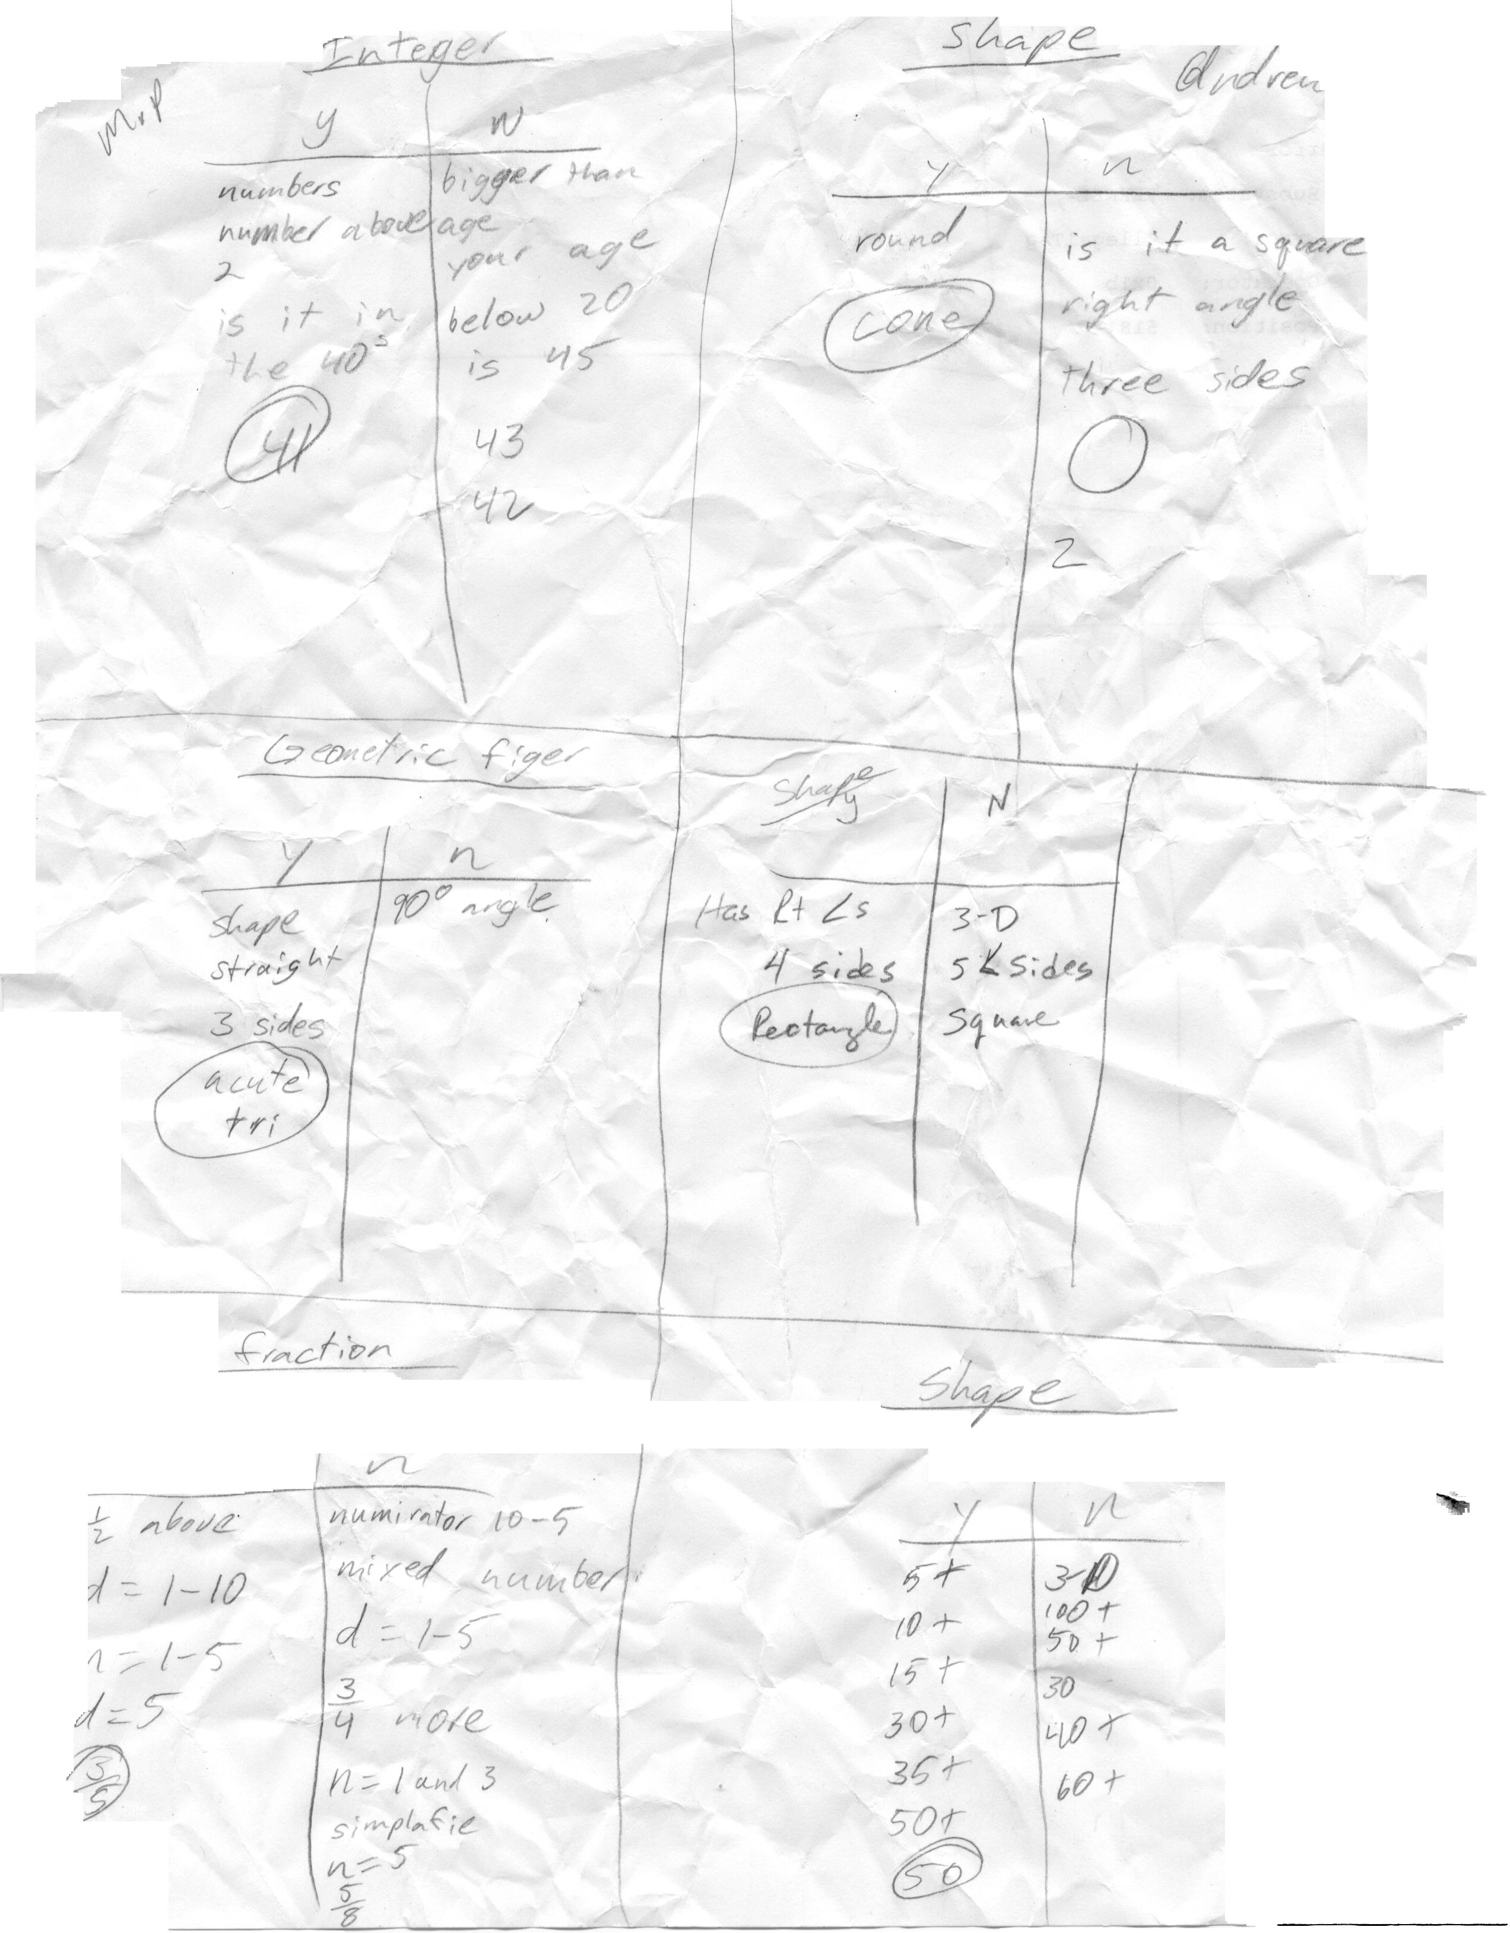
-gon
LIMSST Project Literacy Lesson Reflection Form

Name: | 208 |  | Date lesson was taught: | April 19, 2010
Lesson Title/Topic Areas: Measurement and Area review

Literacy Strategies Used: 20 Questions
The class is to guess a word, measurement, shape, or formula using a maximum of 20 yes/no questions.

Student Response to the Lesson:
My group of 7th graders is very competitive. They want to be the one at the board, in charge, answering the questions. This review activity promoted analytical thinking. Their competitive nature kept them totally engaged. Since this activity they have requested to play it whenever there is free time. Evidently developing literacy can be fun! They have used formulas, vocabulary, numbers, and geometric shapes to name a few. Today we had a shortened period so before they left for the track meet they asked to play so they could review new stuff from the current chapter that deals with surface area and volume.

Lesson Reflection:
Twenty questions became a hit right away. It is a break from the “give them more work of the same variety” routine. They were thoughtfully engaged and learned to ask questions that could narrow the search down quickly. As an example I chose acute triangle as the subject. They figured it out in five guesses. Through this game they reviewed properties of geometric shapes, had to use the appropriate vocabulary, and. found examples in the environment One student looked at a clock and came up with radius (hands of a clock) to use. Another saw a watch and thought of area of a circle. By writing down responses to the questions they moved logically through concepts to arrive at solutions. The average number of questions for this activity was 9.5!

Relationship to Previous Instruction:
This was a review activity so students needed to demonstrate their understanding of the material in this chapter as well as any prerequisite knowledge that aided in eliminating possibilities. When we were done the students comments were positive. Students remained engaged even if they were eliminated. Because of the success we experienced with this activity it will definitely be another one on the list to do again.

