Lesson Plan Template

Name: |  | 305 |  |  |  | Course: |  | Earth Science |  |  |  | Grade: | 8th
Unit: |  | The Earth’s Materials
Big Idea: |  | Convection currents within the mantle cause the plates to move causing earthquakes, volcanoes, and mountain building.
Subconcept: |  | The movement of the plates makes places in the crust for volcanoes to form and different types of magma produce different types of volcanoes.
Literacy Strategy(s): |  |  | KWL
Lesson: |  | Introduction to Volcanoes |  |  |  |  |  |  | Date Taught: | 2/24/10
Learning Objective(s):/
 | Students will be ab/le to |  |  | understand volcanoes are active throughout the world
 | Students will be able to |  |  | Understand different ways volcanoes affect their surroundings
Idaho Standards (or National Standards if no Idaho Standards exist):
Goal 4.1: Understand Scientific Theories of Origin and Subsequent Changes in the Universe and Earth Systems
Goal 4.2: Understand Geo-chemical Cycles and Energy in the Earth System

Detailed Description of Lesson:
Students are given a KWL sheet to fill in what they know and what they want to know. I have them work in pairs so those who have low skills can have some help. Students are then given a Discovery booklet with several articles in it. They are asked to pick two articles to read. After they are done reading then they are to fill in what they learned. After they are done I have them discuss at their table what they have learned. This gives students the opportunity to make sure they have filled in all of the boxes. The next day we have a classroom discussion of what they have learned.

Handouts:
Next Page

Student Work:
Included

What I Know | What I Want to Know | What I Learned

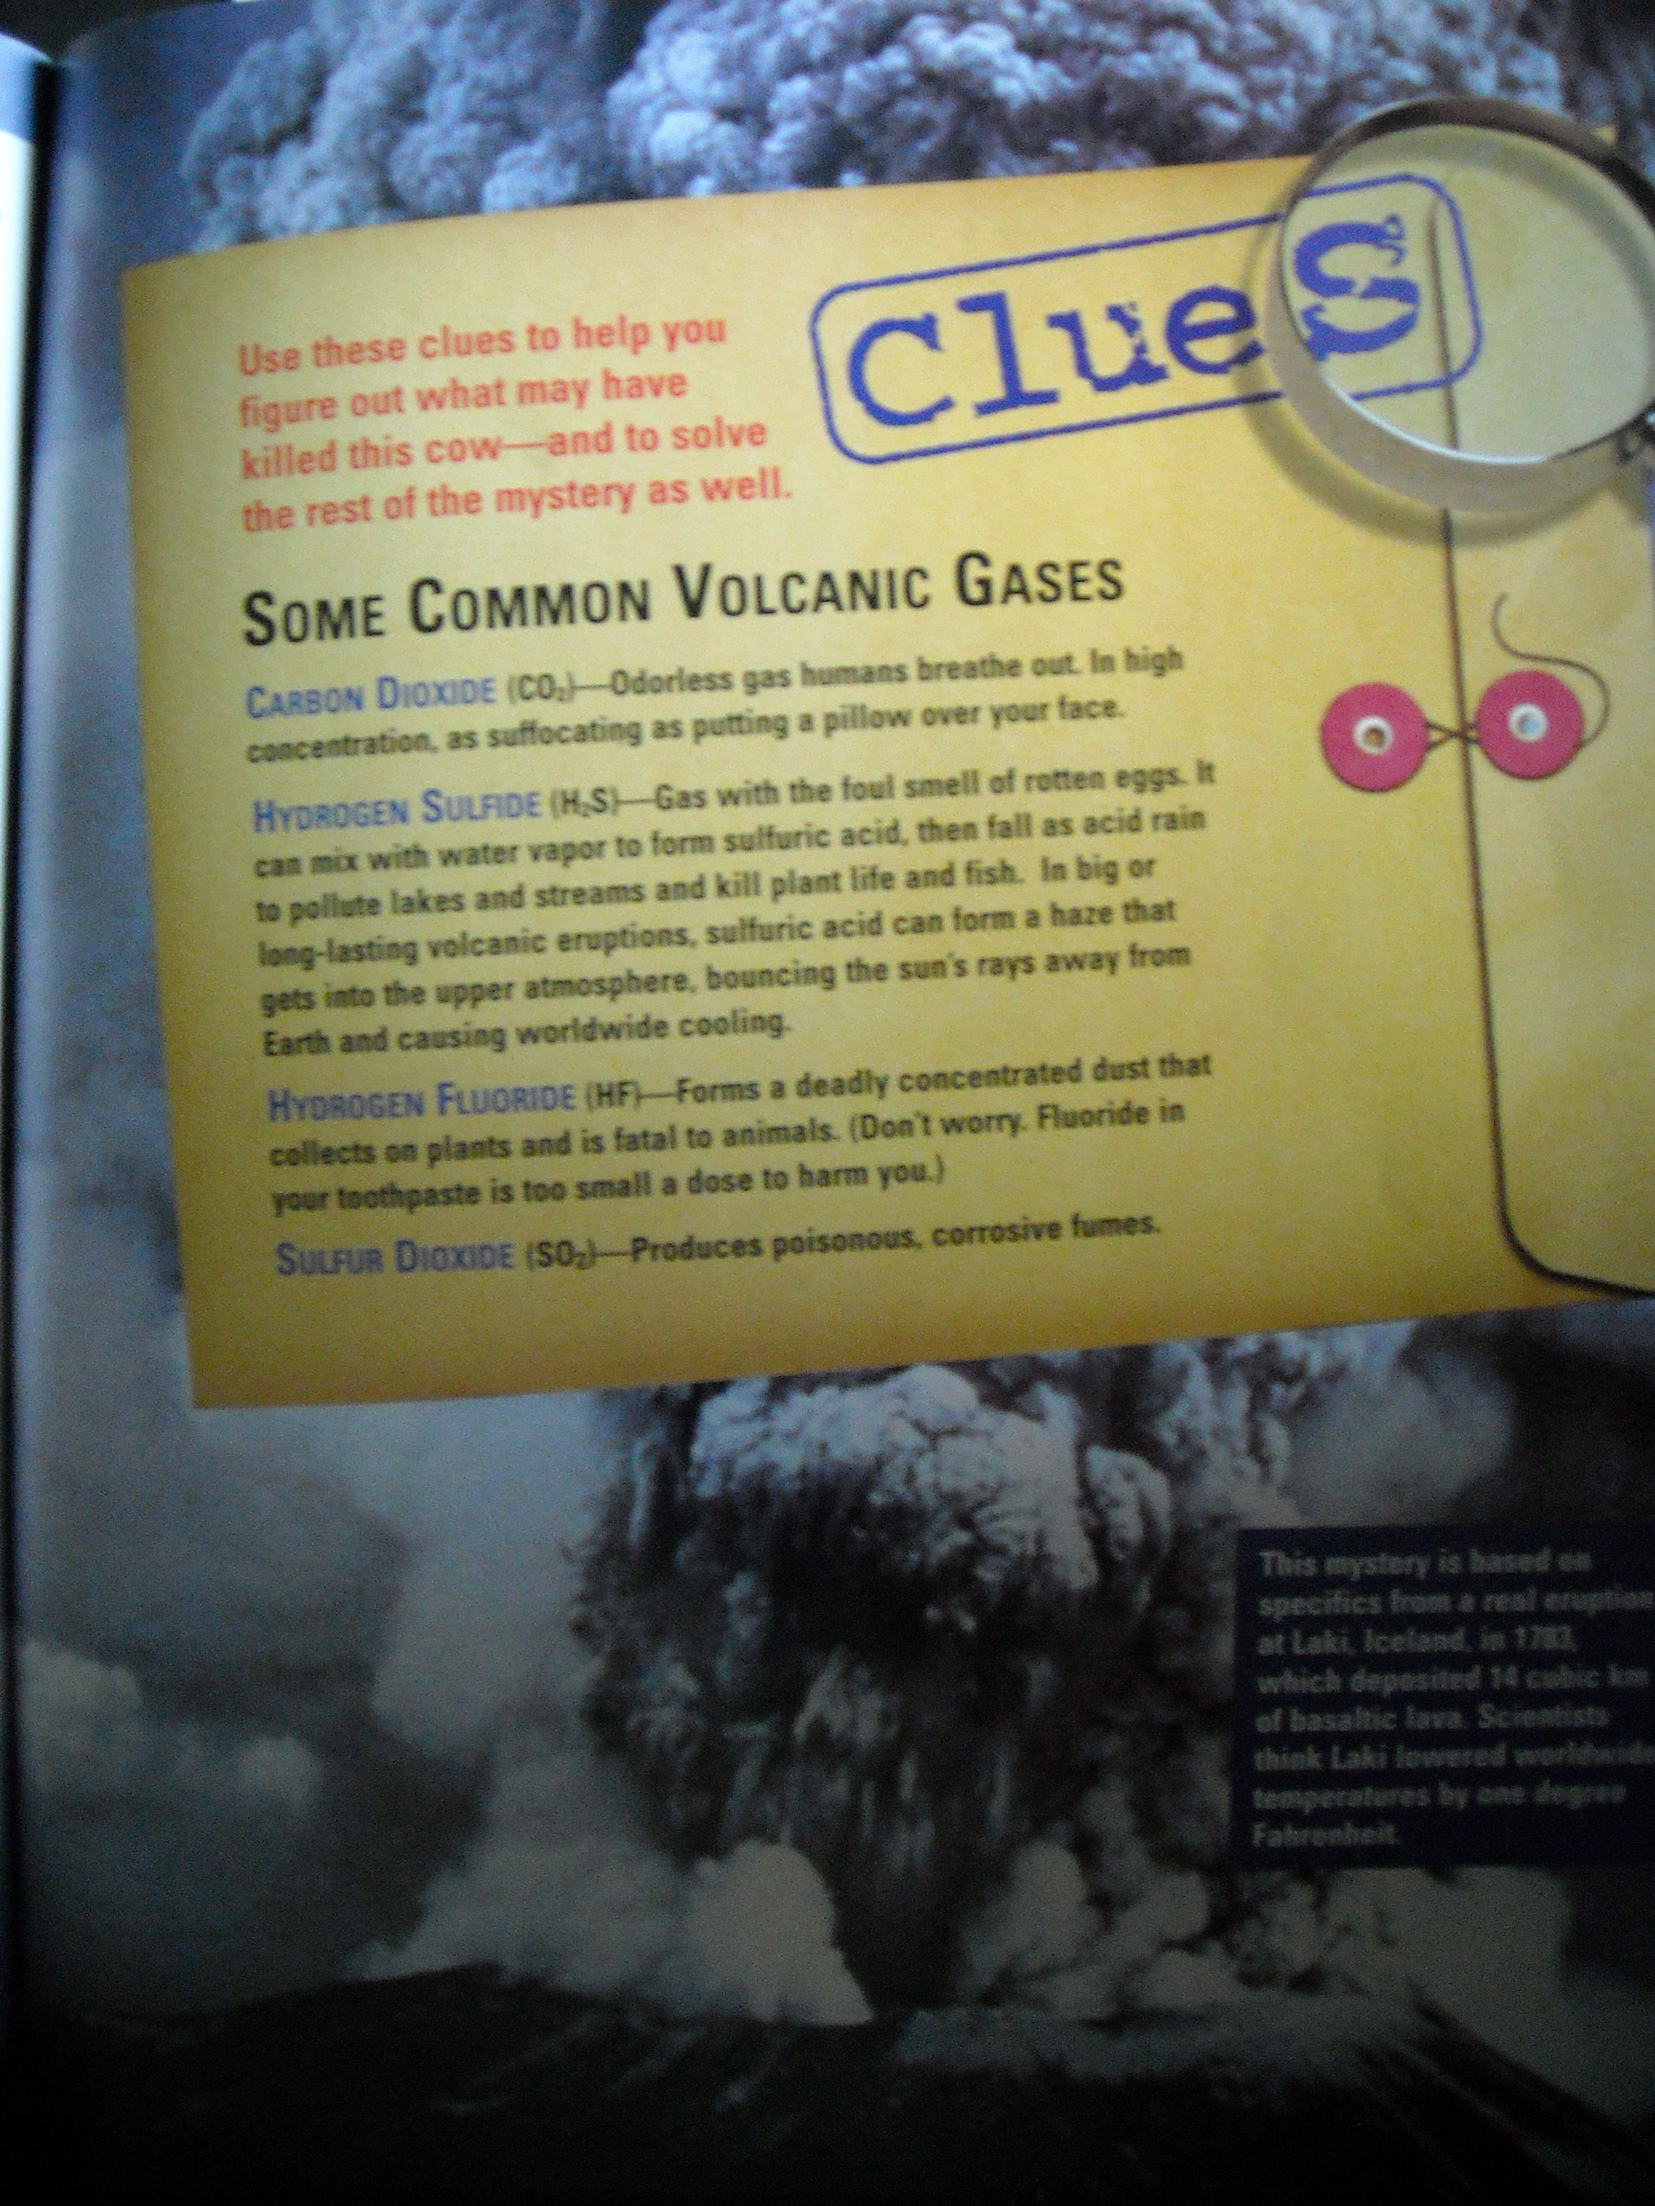
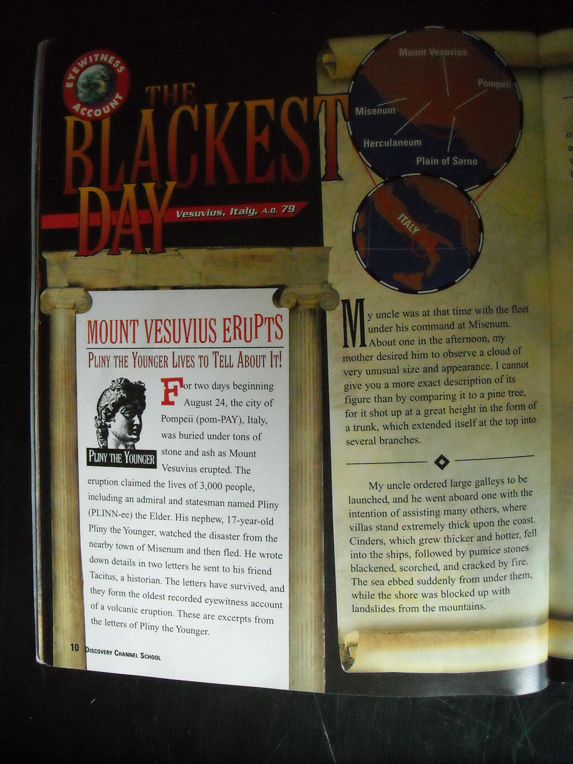
LIMSST Project Literacy Lesson Reflection Form

Name: | 305 |  | Date lesson was taught: | 2/24/10
Lesson Title/Topic Areas:
KWL for volcanoes

Literacy Strategies Used:
I used the KWL to help introduce volcanoes and at the same time assess their prior knowledge. Students list what they want to Know, what they Want to know, and then what they Learned from the text.

Student Response to the Lesson:
Students responded much differently than I expected. I assumed with all their prior knowledge and interest they would have no trouble filling in the sheet, especially considering they were allowed to work in pairs. I am not sure if there were other dynamics involved but it was a real struggle to get them to fill out the sheet. There was a lot of whining involved.

Lesson Reflection:
Overall I think this activity has a several good aspects to it. I like the fact that you can find out what they know and what they want to know all at once. I think this might be a strategy that would work better, or worse, depending on the dynamics of each individual class. I will definitely have to modify this to better suite my teaching style and the particular class I use it in. One thing I could do is have them do the K and the W part together. One thing I tried in two classes was an overall review of what they learned. I found there were some misconceptions I was able to clear up.

Relationship to Previous Instruction:
This was an introductory lesson to volcanoes. It allowed me to find out what they knew and what they were interested in.

