Lesson Plan

Name: |  | 309 |  |  |  | Course: |  | Pre-Algebra |  |  |  | Grade: | 8th
Unit: |  | Polygons
Big Idea: |  | Students will identify angles, triangles, polygons. Students will explore connections and similarities between parts of a circle with parts of polygons using correct vocabulary.
Subconcept: |  | Circle and Polygon Similarities
Literacy Strategy(s): |  |  | Concept Map
Lesson: |  |  |  |  |  |  |  |  | Date Taught: | 5/10/10
Learning Objective(s):
 | Students will be able to |  |  | recognize the similarities between circles and polygons.
 | Students will be able to
Idaho Standards (or National Standards if no Idaho Standards exist):
8.M.4.1.7 Use appropriate vocabulary and symbols.
8.M.4.1.1 Describe and classify relationships among types of geometric figures.
8.M.4.1.5 Identify congruence, similarities, and line symmetry of shapes.

Detailed Description of Lesson:
I tried this in two of my classes. In the first class we discussed and listed the vocabulary that we had been using for the past week or so. These are the ones they came up with: angles, area, arc, bisect, center, central angles, circle, circumference, chord, congruent, diameter, diagonal, degrees, endpoints, intersect, line segments, measure, quadrilateral, radius, rectangle, semi-circle, side, sector, triangles, SSS, SAS, ASA, 360°, and 180°.

Then in pairs or small groups they made a concept map. This time I did walk around the room and ask questions as to how or why they were or were not connecting words. Mostly I asked how certain words connected.

The second class period we generated a smaller list of words and worked on a group concept map first on the white board. I thought that would give them some ideas of how they would or would not set up their concept map.

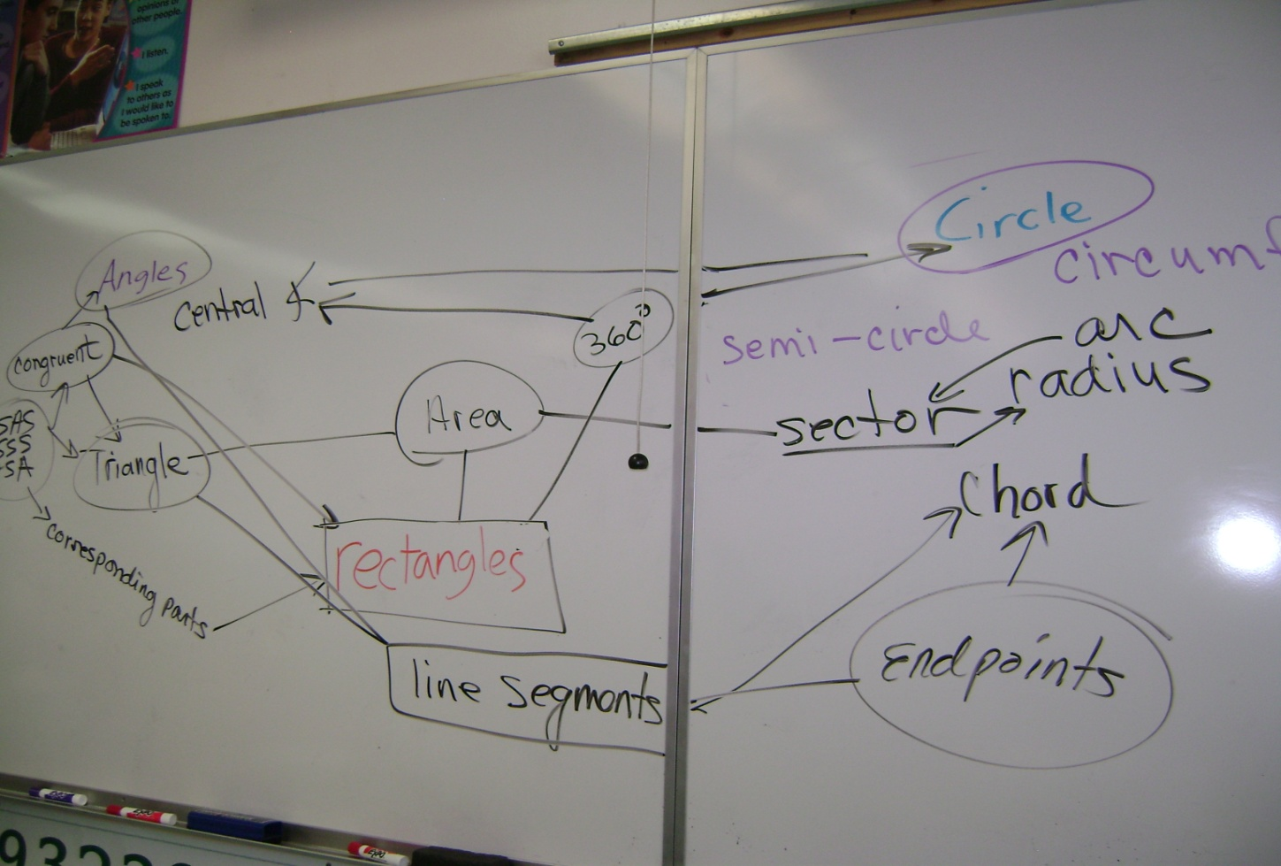

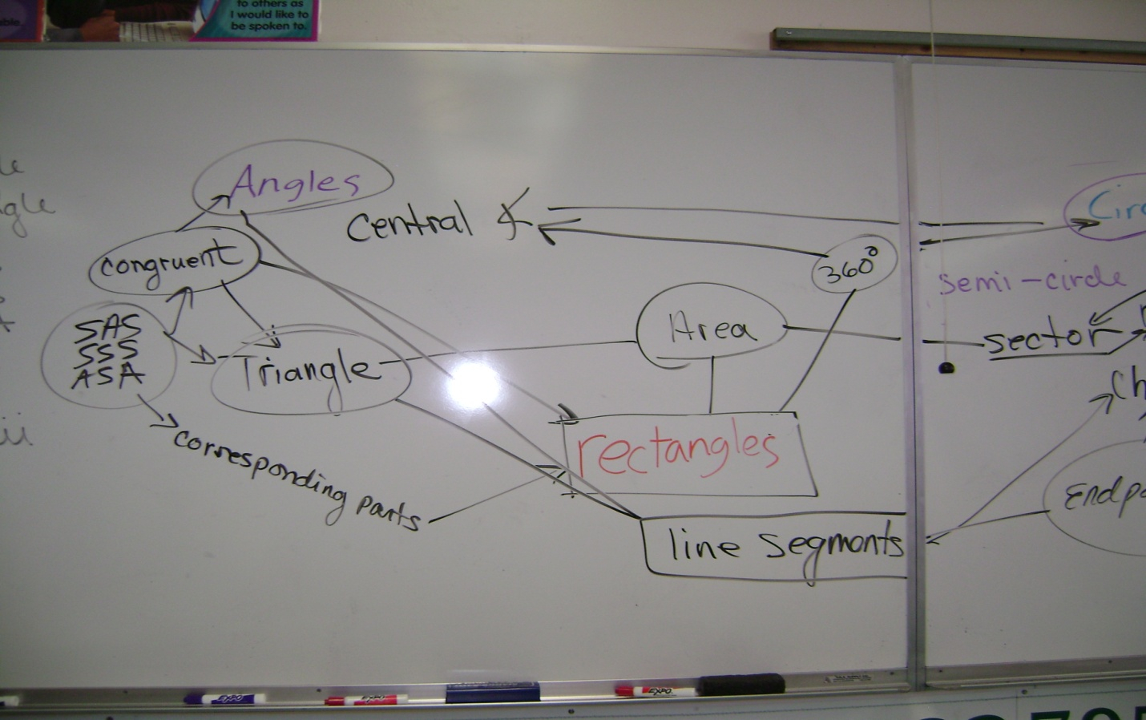

LIMSST Project Literacy Lesson Reflection Form

Name: | Judy Johnson |  | Date lesson was taught: | 5/10/10
Lesson Title/Topic Areas:
Circle and Polygon Similarities

Literacy Strategies Used: Concept Map
I used two different approaches this time. The first class generated a list of all the words they could think up that we used regarding polygons and circles. The second class I confined the word list, or so I thought

Student Response to the Lesson:
The students are always ready to do anything that doesn’t include the text book and they really do try to draw out these concept maps, but they don’t get it. The students had no problem coming up with the vocabulary, but showing all the connections was next to impossible. By the time they were completed there were lines going everywhere. It was the first class that suggested we not use so many words. How insightful are young minds. The second class did better but even with some direction they couldn’t figure out how to lay it out so the connections were easy to make. They too expressed their frustration with too many lines and too many words.

It is difficult to identify which concept map is high, medium, or low quality. This again is because I don’t know what the end result should look like.

Lesson Reflection:
This is my second attempt at concept maps and I am still using too many words with the students pointed out to me. I don’t think I know what the end product should look like. Before I do another concept map I am going to do one myself I think that will help. Also I need to do small concept maps. I was reflecting back on some of the LIMSST papers and came across the WORD SORT. I think if I started with that first them moved into the concept map I will get the results I want. Which is another reason why the concept map might not be working I do not have a clear understanding as to what expect from the students.

As I am re-reflecting I think that the students will obtain a better understanding and actually learn more, meaning remember and make the desired connection with a word sort as opposed to the concept map. The objective is to use with understanding the vocabulary.

As you can tell I am a little frustrated with the concept maps and for now I am putting them on the back burner. The students like the activity, but the results are undeterminable. Next year I will start with the word sort and use the quick writes to help determine whether the students are able to use the vocabulary correctly.

