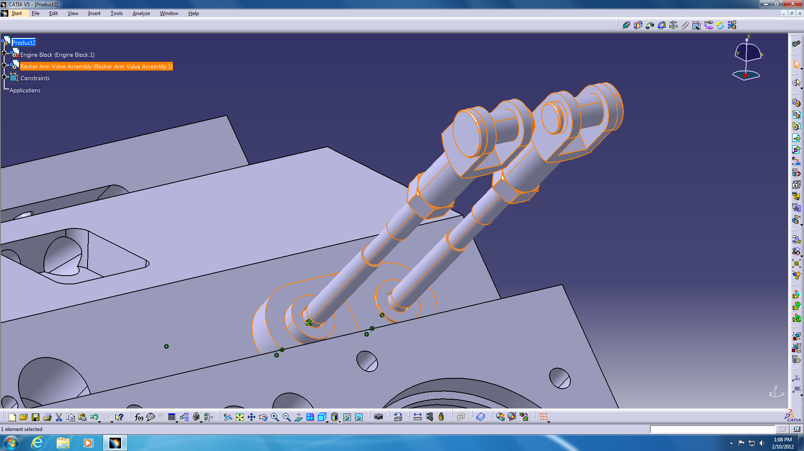
In order to be able to complete the Howell Engine Assembly, we must use the rigid/flexible sub-assembly feature.
In the Rocker Arm Valve Assembly (shown above), we can make the parts move with regard to their constraints. To do this, we must select the desired assembly from the design tree by clicking on it.
Once the desired assembly is highlighted in orange (as shown in image), click the Flexible/Rigid Sub-Assembly button in your assembly constraints toolbar.

The sub-assembly is now flexible and its features are denoted in the design tree by a pink gear on the icon.

