Computational FEA Comparisons
Evaluating Variances in FEA Solutions Obtained from Abaqus, CATIA, and Analytical (Handwritten) Solutions

Jake Elliott
&
Jake Jermyn

Project Overview
The purpose of this project is to compare and contrast the Finite Element Analysis computations of CATIA, Abaqus, and analytical solutions. The examples used in this comparison were taken from Dr. Odom’s ME 341 in the fall semester of 2017. In order to keep the comparisons as close to the same as possible, all computer solutions were held to a similar set of parameters.
Each problem solves for a unique aspect of Finite Element Analysis. Some solve for the deflection of a beam at certain location, others look at stress states, either Von Mises or principal, and lastly one of the problems takes the analytically calculated load and then back solves to find the yield stress that was calculated in the problem algebraically.
This project was an attempt to be able to look closely at the FEA abilities of CATIA and compare it to that of a program that was built for FEA calculations (Abaqus). Knowing that the solutions by hand were done correctly, we were able to see just how accurate each program was in regards to FEA and different shapes and loading conditions.

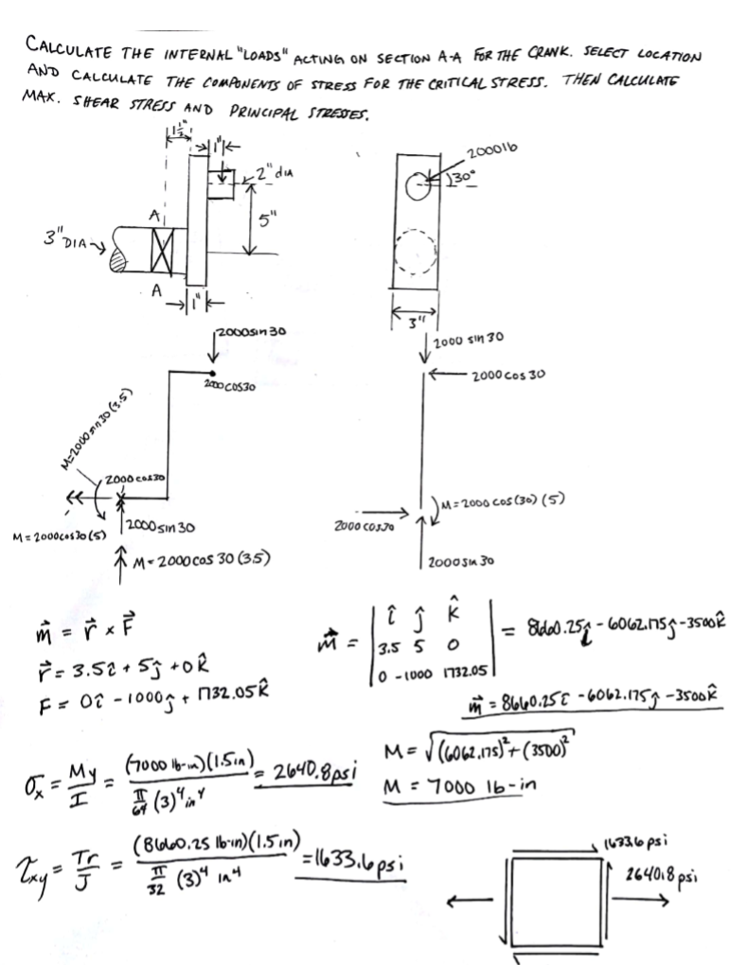
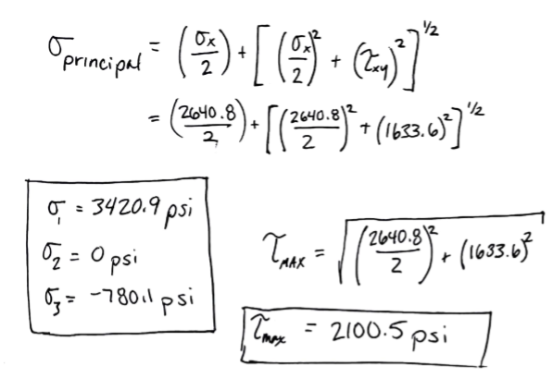
Crank Example – Analytical Solution
This analytical solution produces a maximum stress value of 3420.9 psi at the point of interest.
Crank Example – CATIA Solutions
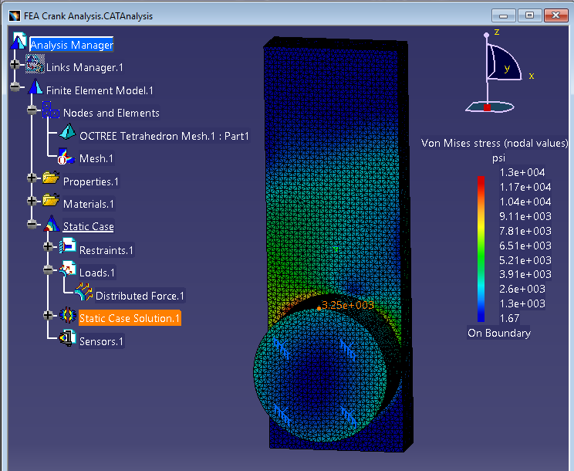

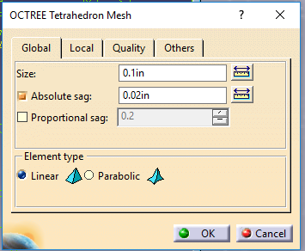

The CATIA generated a Von Mises solution around 3,250 psi at the point of interest. This is not the highest stress found in the specimen, however it is the solution for the correct location. You can see that this analysis was run with a mesh size of 0.1” and an absolute sag of 0.02.”

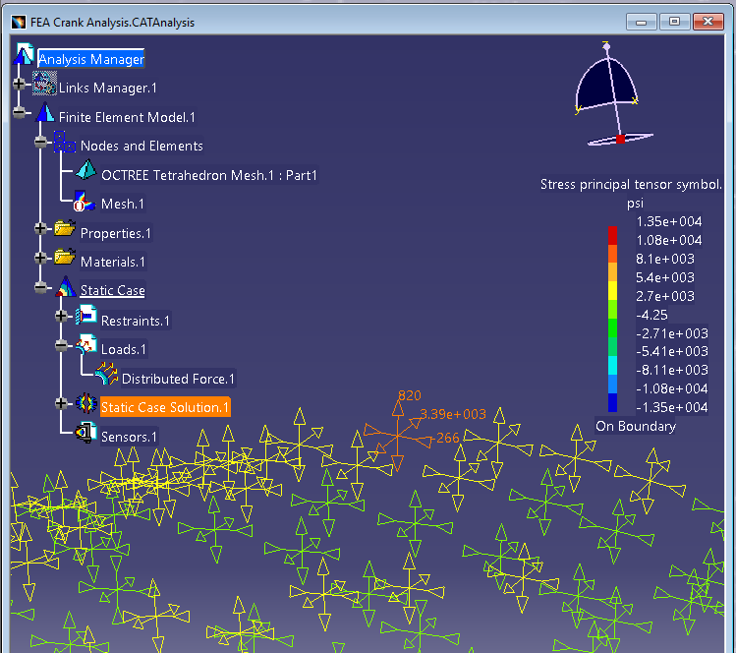

This figure illustrates the CATIA solutions for the principal stress in the Crank Example. The highlighted element is in the same location as the node evaluated in the Von Mises simulation. The principal stress calculated by CATIA is around 3,390 psi, which is extremely close to the analytical solution of 3420.9 psi.

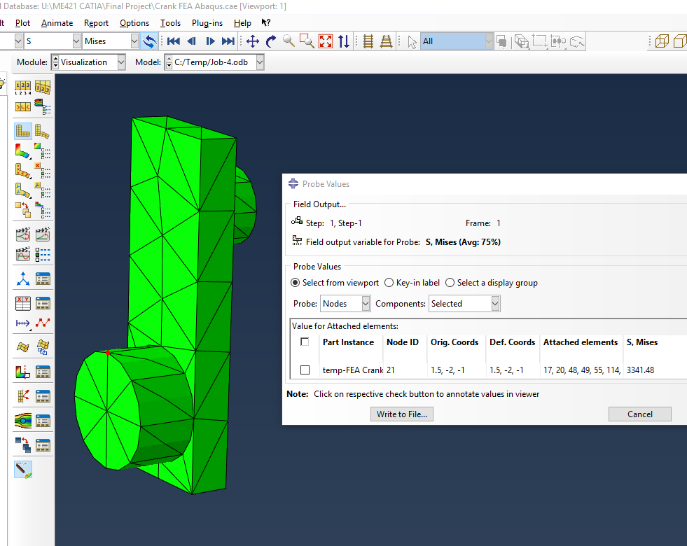
Crank Example – Abaqus Solution

This figure illustrates the stress calculated in Abaqus at the specified node (highlighted in red.) Although the mesh was much less refined in Abaqus due to the fact that the student version only allows FEA examples to be divided into 1000 or less elements, a result similar to the stress calculated in CATIA was found. Here, Abaqus found the Von Mises stress to be about 3341.48 psi.
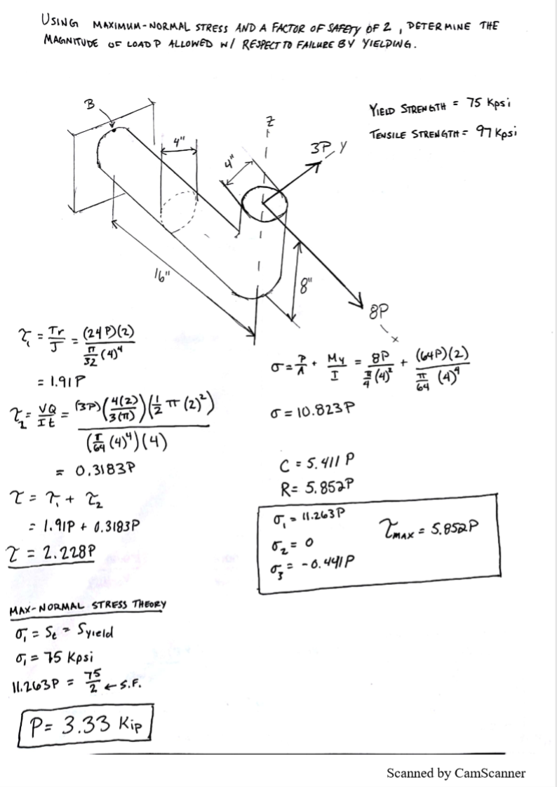
Bar Example – Analytical Solution
The solution to this example, using a Yield Strength of 75 ksi, was a 3,330 lb load. Since it is impossible to calculate loads in CATIA and Abaqus, the load calculated here was used to back solve for the maximum stress, which after applying a safety factor of 2, should be around 37.5 ksi.
Bar Example – CATIA Solution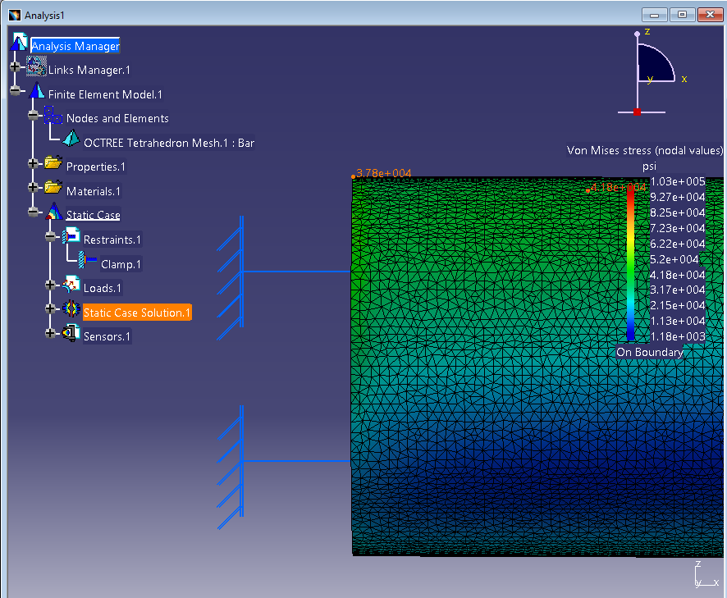

The stress calculated in CATIA at Point B in this bar example was approximately 37,800 psi, which was only about 300 psi over the stress that we expected to find based on the analytical solution. There are many possible factors that may have caused this, but we think that rounding intermediate numbers in the analytical solution may be the main cause of this discrepancy.

Bar Example – Abaqus Solution
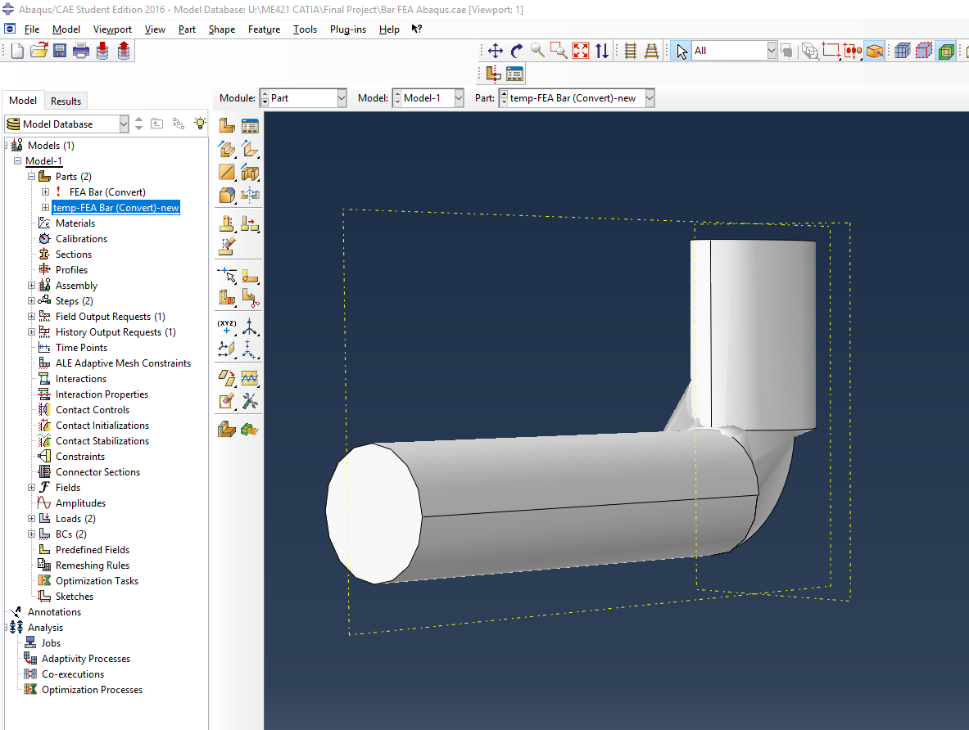

We were unable to obtain any solutions from Abaqus for this example, as the file refused to convert properly from a CATIA part into Abaqus, as you can see by the interesting geometry displayed in this image.

Castigliano Beam Deflection – Analytical Solution
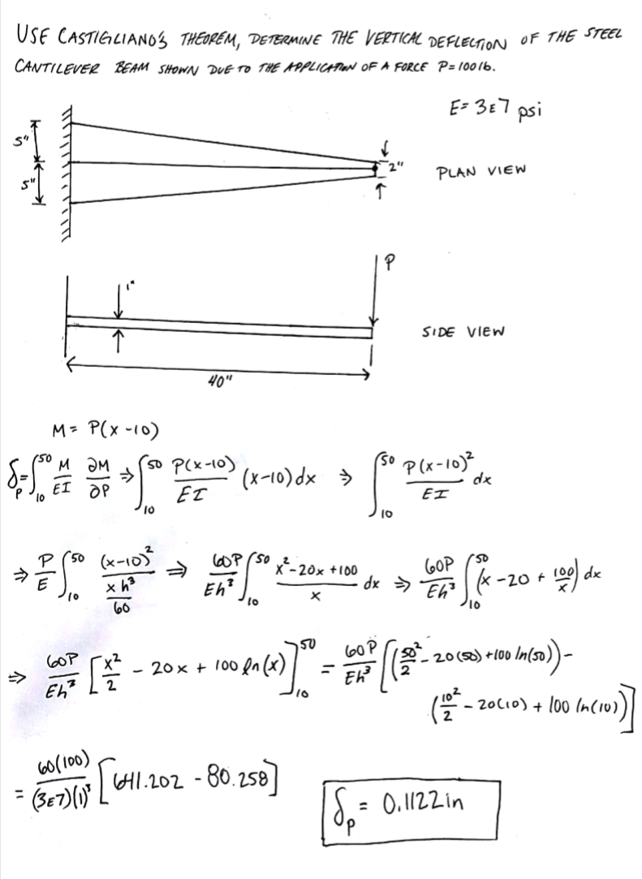

In the above hand solution, the request of the problem is to find the deflection of this part where it is loaded by using Catigliano’s Theorem. Following the steps, it can be seen that the hand calculation to find the deflection to be 0.1122“ at the point in which the load is applied.
Castigliano Beam Deflection – CATIA Solution
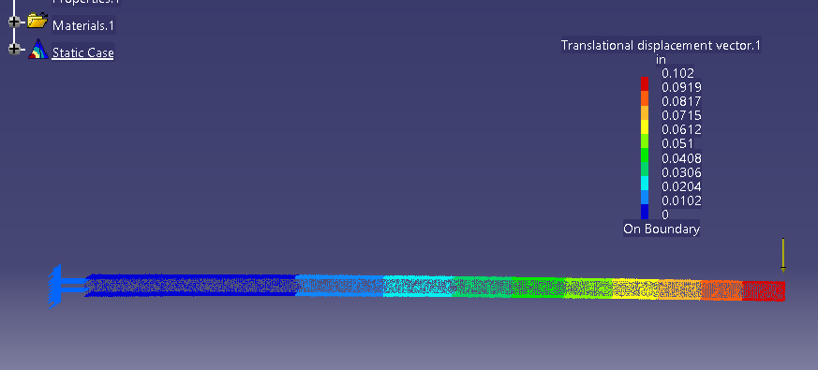

In order to accurately compare the beam above and its respective hand calculations, the part needed to be modeled in CATIA and then put under identical loading conditions. In the picture above, you can see on the left side there is a cantilever support holding that side in place and that there is also a force on the right side of 100lbs. Using the deflection solution and the color scale above the part, you can see that on the far right end of the part, the location of the largest deflection, is deflected down by 0.102”. In this part, the mesh size was 0.1” and the absolute sag was 0.02”

Castigliano Beam Deflection – Abaqus Solution
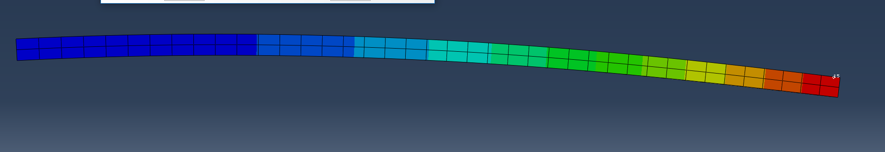
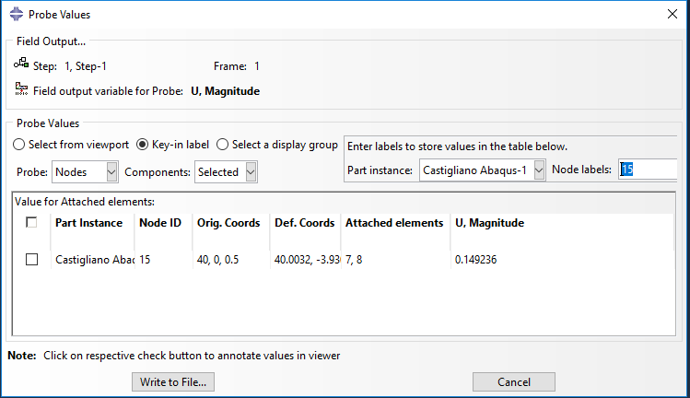
In these two figures above, the deflection of the same beam as above is depicted in a similar way to the CATIA beam. The colors all represent a different magnitude of deflection of the beam. Using the Probe Values tool in Abaqus, the deflection at node number 15, which is the node that the load was placed on, was able to be seen (the small white dot above the red section. Abaqus calculated it as a deflection of 0.1492in downwards. This is a little bit farther off than the hand calculations or the CATIA Solution.

L Beam – Analytical Solution
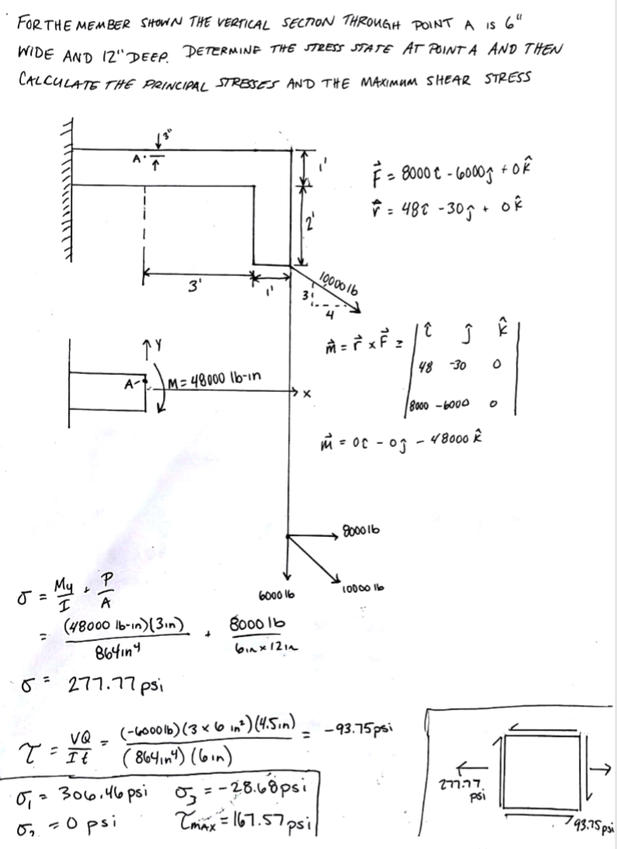
This problem started off with the L beam seen above. It was asking for the principal stresses and maximum shear at point A. In the analytical solution, it can be see that the principal stress is 306.5psi and there is a maximum stress at 167.57 psi.

L Beam – CATIA Solution
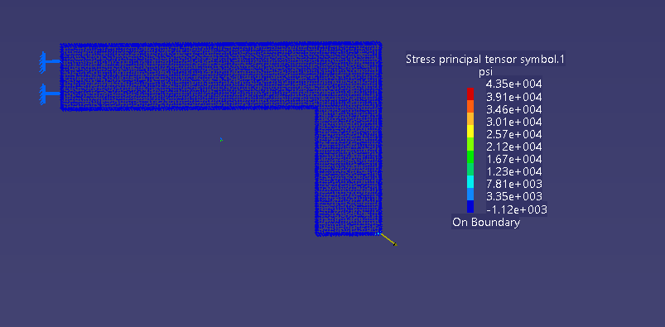

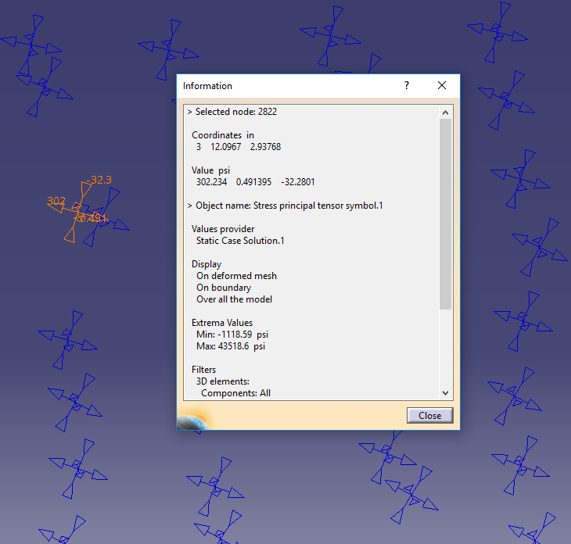

In the CATIA solution, there were many problems encountered. The hardest problem to overcome was the size of the mesh due to the size of the part as a whole. In an attempt to keep the mesh size the same between the four different cases, the part’s calculations turned the size of the file from manageable to unruly. It was taking over 10 minutes to even save the part, so to remedy this, the mesh size was changed to 0.5” and the absolute sag 0.2”. After that problem was fixed, the next one arose. There is no easy way to find an exact spot on a part in CATIA, so an assumption and hand measurement was completed to find the point of interest. That point of interest ended up being Node 2822, which highlighted in the second photo. It can be see that the value of the principal stress is 302.23 psi, which is very close to the hand calculated 306 psi. The comparable values between the analytical calculation and the CATIA solution prove that the solution in CATIA can be used as a true answer.

L Beam – Abaqus Solution
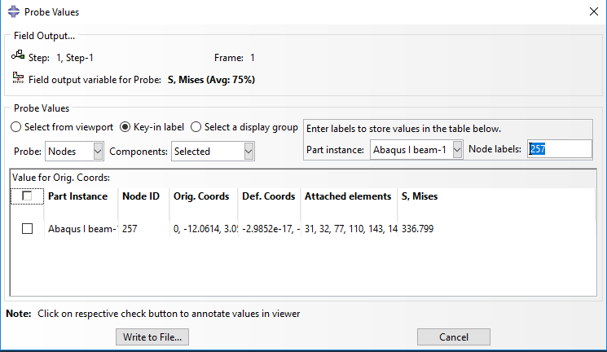
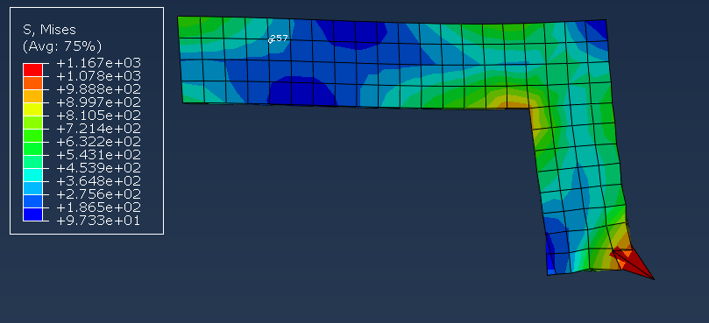

In the Abaqus solution, there was a lot less of a headache than in CATIA. After importing the part from CATIA to Abaqus, it was a fairly seamless process to get the stress visualization that can be seen above done. Using Node 257, which is the location of A in the analytical solution above, the calculated stress can be seen as 336.8 psi. This matches closely with the 306 psi from the analytical solution, but is not as accurate as the CATIA solution. The main reason for this is most likely the size of the mesh. Because the student version of Abaqus only allows for 1000 elements maximum, it was impossible to get a more precise answer. If the size of the mesh were to be smaller, than it is very possible that the answer in the Abaqus solution would be as precise as the CATIA solution.
Conclusions/Discussions
Throughout this project, many things were learned about the FEA computation programs in both CATIA and Abaqus. Here are some of the more significant discoveries resulting from this project:
- The Student Edition of Abaqus is not as accurate as it can be because of the 1000 element maximum.
  - Saying that, even though the Abaqus mesh was larger than the CATIA mesh, it was still relatively accurate.
- In CATIA it is only possible to evaluate external stresses and not internal ones, unlike Abaqus.
- Abaqus handles larger parts better, but when the shapes become more complex, it doesn’t work as smoothly.
- Transferring part files between CATIA and Abaqus is troublesome.
 | Crank | Bar | L-Shape | Castigliano Beam
Handwritten | 3420 psi | 75000 psi | 306.46 psi | 0.1122 in
Abaqus | 3249 psi | *Did not Work | 336.8 psi | 0.1492 in
% Error | 5% | N/A | 9.9% | 33.0%
CATIA | 3390 psi | 75600 psi | 302.23 psi | 0.102 in
% Error | 0.877% | 0.8% | 1.4% | 9.1%

Looking at the table above, it can be seen that CATIA, in general, was much more precise compared to Abaqus. This could be explained by the differences in mesh size, which comes from the fact that the Abaqus that we used was the Student Edition. If we were to use the full sized Abaqus program then it is very possible that the answers would have correlated much more closely. Another thing that could change the correlations seen above would be the collective knowledge of Abaqus between us. If we were more proficient in the program, then we would probably be able to find better solutions to the problems we were looking for.

