Adams Car
How to
Adjust Hardpoints to Modify a Suspension

In this tutorial we will go over the basics of hardpoints and what some of the meanings of a few of the abbreviations that are found in the suspension, and then have you do a simple hardpoint adjustment to create a suspension similar the Hybrid Formula 1 of 2011.
Changing the Units
Once you have Adams/Car open, make sure you are in the standard interface and have a subassembly or assembly with your suspension in it.
Before we get started select Settings from the tool bar and then select Units, a box pops up where you can adjust the units to work in. Select IPS to work in Inches and Pounds.
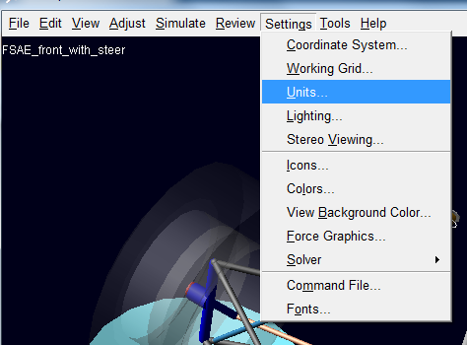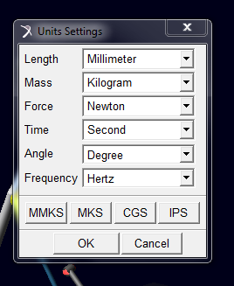

Navigating to Hardpoints
Once you have Adams/Car open, make sure you are in the standard interface and have a subassembly or assembly with your suspension in it. Then select Adjust then Table from the tool bar as seen
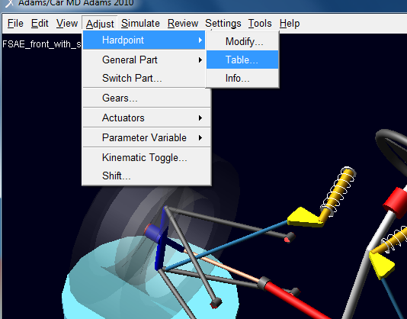
Once you have this selected a table will pop up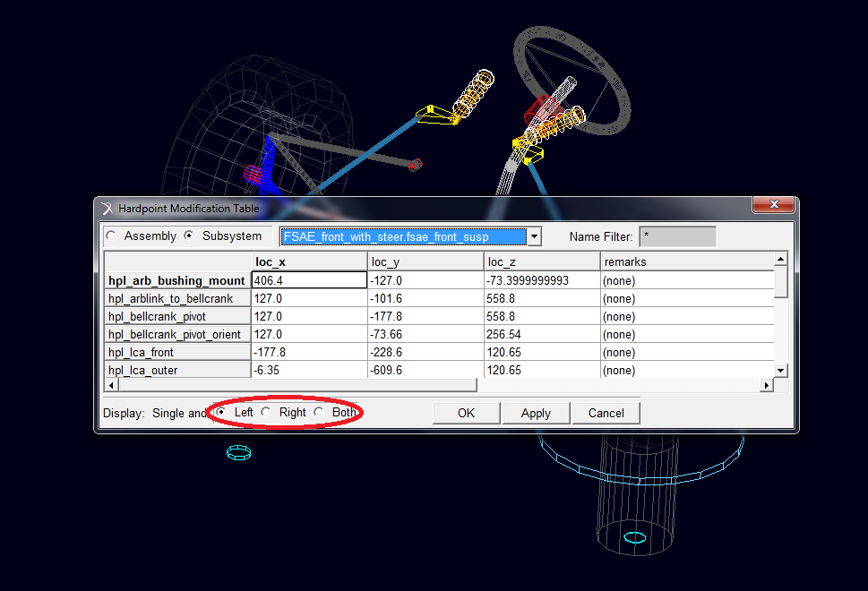
The suspension subsystem is symmetrical and therefore it is easiest to just adjust one side of the suspension and have the other side reflect the change. The circled section is what points on the assembly are being called out. Currently we have selected left, this means that when we adjust a hardpoint it is adjusting the left point with reference to the origin. The right side is then adjusted the same as the left. Keep this in mind when working, because sometimes deciding if the Y direction is positive or negative depends on whether you are working in the right or left.
These are some of the abbreviations in a typical suspension assembly; they start to get easier to understand the more you use ADAMS.
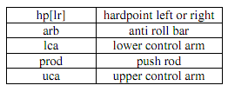

When adjusting hardpoints in an Assembly we have the option to either select Assembly or Subsystem. The difference is when Assembly is selected all of the hardpoints are available to be adjusted; whereas when Subsystem is selected you have to pick which subsystem you want to work in to adjust the hardpoints.
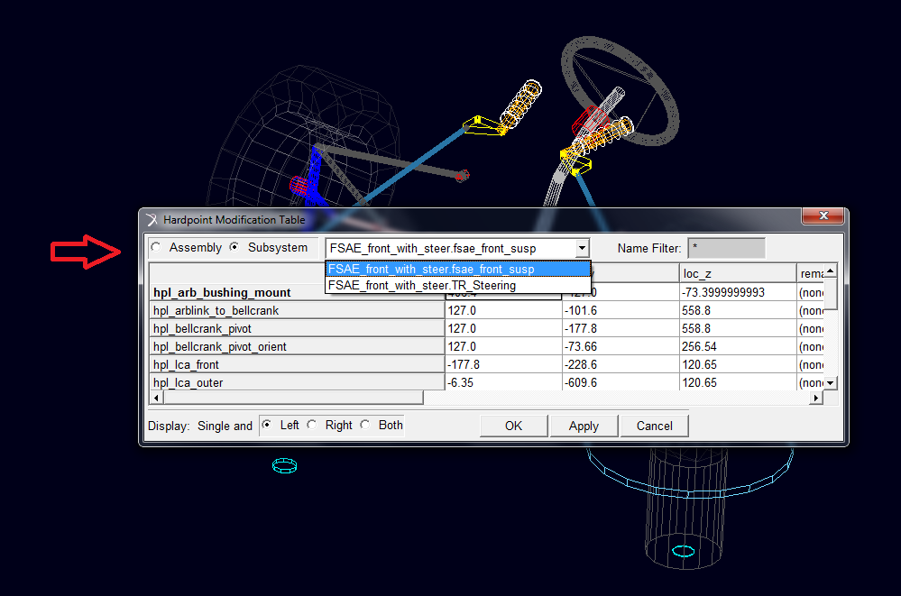
Actually adjusting the hardpoint is as easy as selecting the one you want to change and putting in a new number and then select Apply or Ok. Below are the points that the FSAE hybrid suspension is at.

