ME 345 – HTx Fall 2023 Week 7 Homework

Problem 1:
Update your resume and attend the Career Fair.

Problem 2:
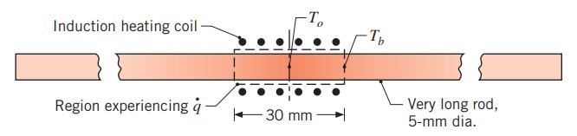
The center portion of a very long rod that is 5 [mm] diameter is subjected to heat treatment with induction heating. The rod has a thermal conductivity of 25 [W/m*K]. The center portion is 30 [mm] long and experiences uniform volumetric heating of 7.5 x 10⁶ [W/m³]. The unheated portion protrude from each side and experience convection with h = 10 [W/m²K, and T∞ = 20 °C. Ignore any convection or radiation heat transfer from the 30 [mm] portion of the rod. Calculate the following:
- Steady-state temperature of the middle of the rod (T₀)
- Steady-state temperature of the rod where it exits the heating portion (T_{b})
- Steady-state rate of heat transfer from the unheated portion of the rod.
- Minimum length [mm] of each side of the unheated portion of the rod necessary to assume it is a “very long rod” is a valid assumption.

Problem 3:
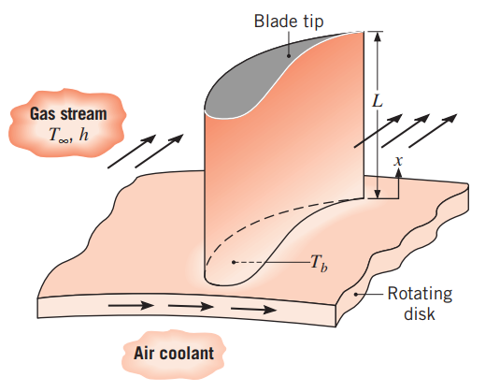

The blades on a gas turbine are in a very hot environment. To deal with this the blades are made of Inconel (with k ~ 20 [W/m*K], but this alone wasn’t enough to keep the blade tip below the maximum allowable temperature of 1050 °C. One idea to help keep the blade cooler is to use cooling air through the ring base (where the blades attach). This cooled air will keep the base temperature at a constant
300 °C.

Some parameters about each turbine blade are:
- Uniform cross-sectional area of 6 x 10⁻⁴ [m²]
- Perimeter of 110 [mm]
- Length of 50 [mm]
- Outside surface experiencing convection with h = 250 [W/m²K], and T∞ = 1200 °C
Calculate the following two different ways. 1) Assume the blade has an adiabatic tip, and 2) Assume the blade tip is experiencing convection heat transfer (same h and T∞ as the rest of the blade).
- For each case what is the maximum SS temperature experienced by the turbine blade?
- For each case what is the heat rate transferred from the blade to the ring base?

