ME 345 – HTx Fall 2023 Week 9 Homework

Problem 1:
The figure below shows a temperature distribution on either side of the laminar boundary layer over an isothermal plate. There is an example temperature distribution shown at x = x₂.
- Determine if the plate is being heated or cooled by the fluid flowing over the plate. Explain your reasoning (1-2 sentences is fine)
- Sketch (with reasonable detail) the temperature distribution at x = x₁, and x = x₃. Make sure you show the slope of the T vs. y clearly at a few key places (like at the surface, and at δ_{t}).
- Based on your sketches in part b, which location (x₁, x₂, or x₃) has the largest heat flux?
- You get to make another sketch! Now I would like you to sketch the temperature distrubution, but only at x=x₂. However, I would like you to do this for two additional cases. One where the free stream velocity is lower than the example figure, and one where it is higher. Remember that both the velocity *and* thermal boundary layers will become thinner (shorter) as the free stream velocity increases.
- Based on your sketches in part d, which velocity (lower, as-shown, or higher) will have the largest heat flux?
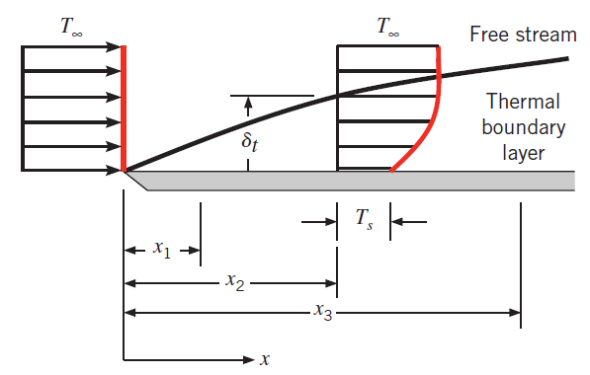

Problem 2:
Fluid flows over a surface. At a particular location the temperature and velocity profiles are described by the following equations:
$$Velocity:u\left(y\right)=Ay+By^{2}-Cy^{3}$$
$$Temperature:T\left(y\right)=D+Ey+Fy^{2}-Gy^{3}$$
Coefficients A through G are all constants. Calculate the following:
- Derive an expression for the friction coefficient C_{f} in terms of fluid properties, u∞ and the profile coefficients above
- Derive an expression for the convection coefficient h in terms of fluid properties, T∞ and the profile coefficients above

Problem 3:
Liquid water flows across a flat steel plate. The water has a temperature of T∞ = 25 °C. The upper surface temperature of the plate is T_{s,1} = 40 °C, and the lower surface temperature of the plate is T_{s,2} = 100 °C. The plate is 0.35 m thick, and the surface temperatures are at steady-state conditions.
Looking up thermal conductivity of water and steel we get
k_{steel} = 61.7 [W/m-K], and k_{water} = 0.62 [W/m-K].
Perform the following:
- Doing an energy balance at the surface-water interface, calculate the convection coefficient.
- At the surface, calculate the temperature gradient of the steel [°C/m]
- At the surface, calculate the temperature gradient of the water [°C/m]

