Data Transfer from Mastercam X2 to HAAS CNC Lathe
(Using a Floppy Disk)

PART ONE: Save the Code to 3.5” Floppy Disk
- Make sure MasterCAM is talking to the correct CNC machine. If you see “Generic” next to “Properties” then you are NOT connected to the correct machine.
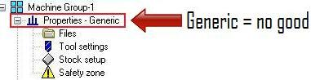
- To assign a specific machine to MasterCAM (for post-processing purposes) expand “Properties” under “Machine Group” and double click “Files”.

- To choose a specific CNC machine, click the “Replace” icon in the “Machine Group Properties” window. After you select “Replace” a new window appears titled “Open Machine Definition File”. Select the Haas Lathe file and then click “Open”.
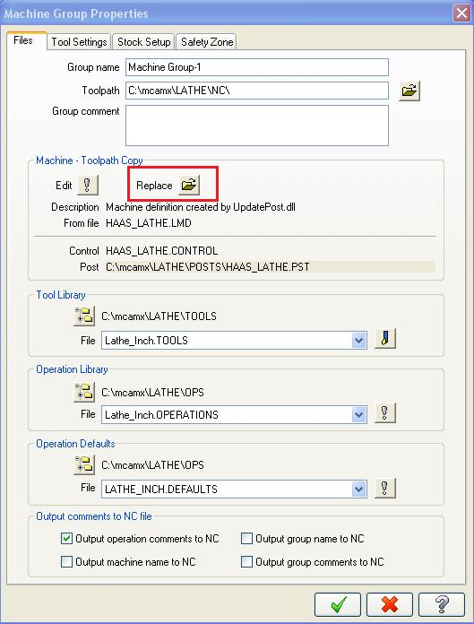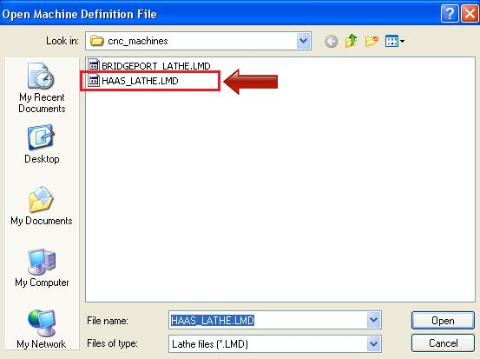
Select the “OK” button from the “Machine Group Properties” window to complete the machine assignment.
- In the “Toolpaths” window press the “Select All Operations” button. Then select the “Regenerate All Selected Operations” button.

- Select the “Post Selected Operations” button. This will bring up the “Post Processing” window shown below. Make sure the “Send to Machine” check box is NOT selected as shown below. 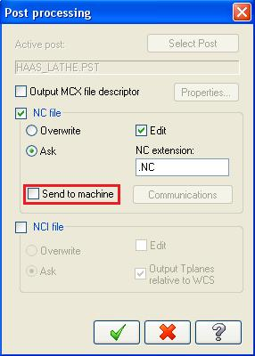

- Insert a 3.5” floppy disk into your computer station. Click the okay button in the “Post Processing” window. A new window will appear titled “Save As”. Select your floppy drive as the destination folder. Enter a file name that you will remember. Ensure the file name does not exceed 8 characters and does not contain any spaces or special characters. For example, “BODY.NC” is an acceptable file name. Click the save button when finished.
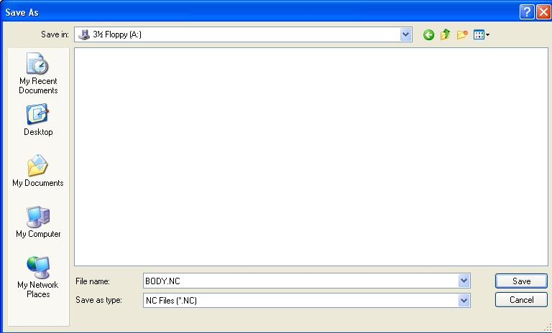

- After you save your NC file a new window will appear showing all of the G-code for the data you are transferring. When you close this window the data will be sent to the 3.5” floppy disk automatically.

PART TWO: Retrieving Code from the Disk on the Lathe
- Insert the floppy disk into the CNC machine’s floppy drive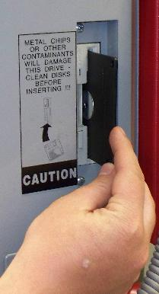. Press “LIST PROG”. Scroll down and highlight “ALL” on the screen using the arrow buttons.

- Type the filename you saved on the 3.5” floppy disk using the CNC control panel while making sure to include the file extension “.NC” at the end of the file name.

- Press the F3 button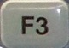 on the control panel to read the file from the floppy disk.

- At this point the Mill or Lathe has loaded the code. Press the “MEM” button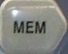 and you are free to begin your operation. If the machine does not read the disk then the disk might be bad and you may need to load your program on another floppy disk.

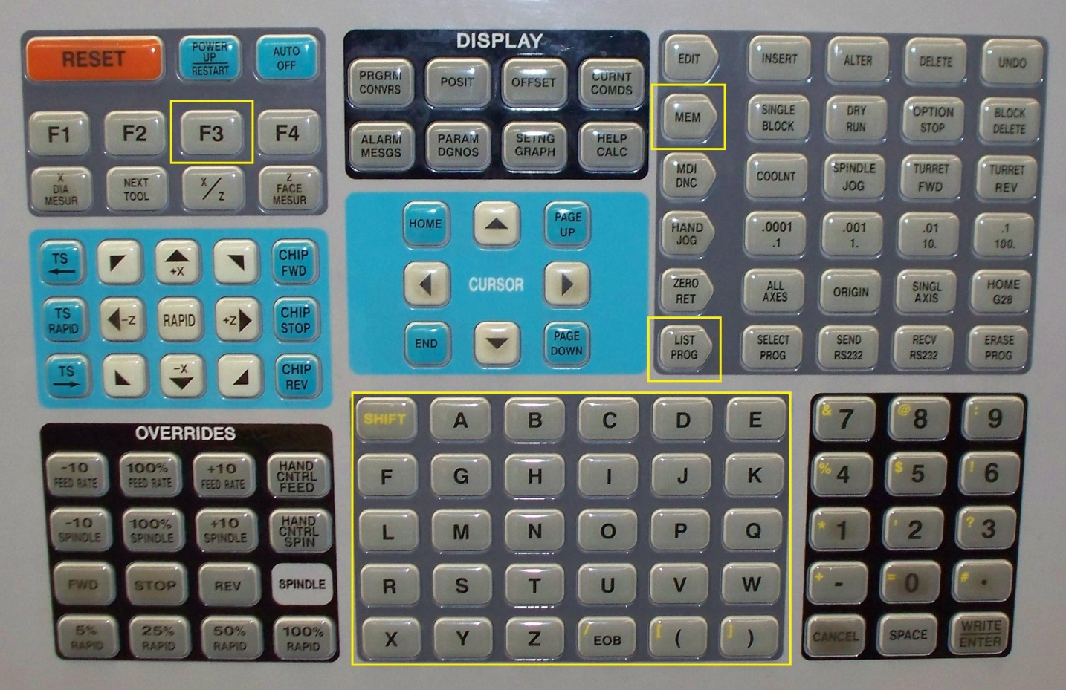
4
2
1
3

