GEAR CHANGE FOR MANUAL MILL
Gear Change Lever
- Machine must be off and at a complete stop to change gears.
- Push gear lever in towards machine while turning to desired position.
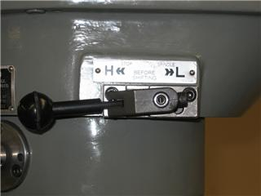
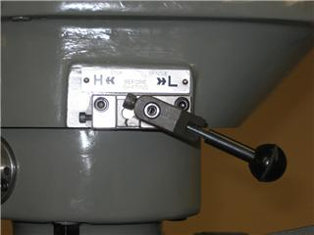

High Gear Position
Low Gear Position

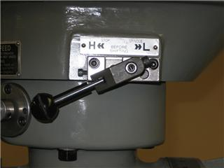
- Manually rotate the spindle back and forth to ensure the gear is engaged.

Not in Gear

- Start machine and continue milling.

NOTE: If milling in low gear,
the mill must be run in reverse

