Laser Cutting

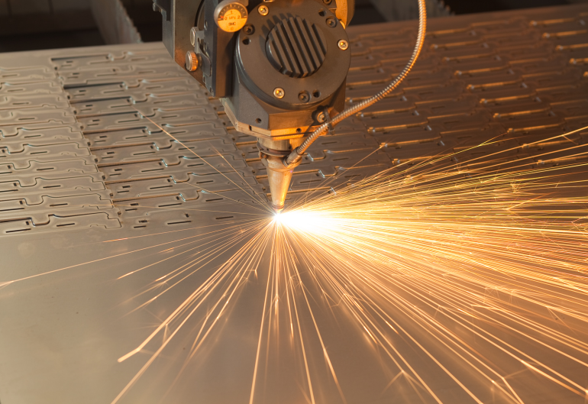
Laser cutters use a focused laser beam to melt, burn, or vaporize the material being cut. The most common laser cutter for metals utilized the melt and blow method where the material being cut is melted by the laser and blown away by a high pressure stream of gas. Laser cutting is often used to cut intricate designs into sheet metal although it does have other uses. A high precision laser micro jet cutting device also exists. This device uses a low pressure stream of water to guide the laser beam and also helps with material removal and helps cool the part as it is being cut.

Uses:
- Cutting
- Boring
- Trimming
- Scribing
- Engraving

Tolerance:
Down to 0.001 in

Advantages:

- High speed cutting perfect for multiple complex parts
- Extreme accuracy in cutting procedure
- Accuracy is not dependent on the depth of the cut
- Cut leaves a high quality finish
- Small area of heat effected material which allows for less chance of warping
- Relatively low cost, quotes are available at most companies

Disadvantages:

- Extreme heat exposure at point of cut
- Changeover time from cutting iron to aluminum is high. Most companies only cut ferrous materials unless a large aluminum order is made.
- Heat discoloration may occur

Companies offering Services

Precision Cutting technologies

16208 East LaCrosse Lane
Spokane, WA 99216

PH: (509)-922-8755
FX: (509)-622-8746
Web: http://www.precisionh2o.com

Additional capabilities:
- Water jet cutting
- CNC lathe work

Technifab Inc.

E. 5714 First Ave
Spokane, WA 99212

PH: (509)-534-1022
FX: (509)-534-1183
Web: http://www.technifab.net

Additional capabilities:
- Forming
- Punching
- grain finishing
- rolling, welding
- plasma cutting

Forest steel

7448 Aqua Circle
Dalton Gardens, ID 83815

PH: (208)-762-4766
FX: (208)-762-5210
Web: http://www.foreststeel.com

Additional capabilities:
- Laser cutting
- Flame cutting
- Plasma cutting
- Breaking
- Shearing
- Sawing
- Steel rolling

Additional Information:
- Large stock of material on hand
- Ships to Pullman regularly

