CHECKSHEET FOR LESSON 1 – PARTS ASSIGNMENT (HW4)
(Submit this sheet as your assignment coverpage)

NAME: _______________________ SECTION #: _____
/5

Design Layout Final Products
___ Thoughtfully completed tutorial log
___ 5-6 visually-descriptive screen captures of the feature creation process
___ Clear and concise captions with each screen capture to explain the image (practice your technical writing skills)
___ Organized layout with appropriate number of images (~2-4) per page

Above and Beyond (Exemplary)
___ Exceptionally meaningful/insightful yet professional captions
___ Other:_______________________________________________________________________
Point Deductions
___ No cover page (-0.5)
___ Not a .doc/.docx (-0.5)
___ Incorrect filename (-0.5)

TUTORIAL LOG

Tutorial(s):

- Outline the main contents/sections of the tutorial.

- What were the most difficult parts of the tutorial? Why?

- What new discoveries/insights did you gain as a result of doing the
tutorial(s)? When might these be applied?

- What unresolved questions were generated by the tutorial?

- What recommendations, if any, do you have for improving the tutorial
or its use in ME 301?

PROCESS DOCUMENTATION (example format using Insert -> Table -> and selecting a 2x3 grid)
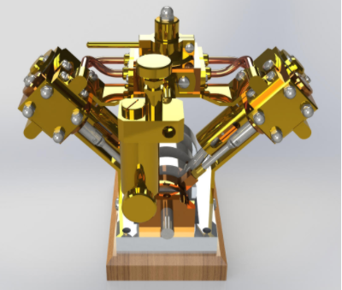 | Rendered perspective view of the V-Twin Steam Engine from the Spring 2020 semester.
Screen Snip 2 | Descriptive Caption 2
Screen Snip 3 | Descriptive Caption 3
Note: Add more rows to the table by placing your cursor in the last cell and hitting “tab”, or by hovering to the left of the lowest line and hitting the “+” icon that pops up, or by right-clicking in a cell and selecting the desired options from the “insert” menu. If you want, you can hide the table grid lines by right-clicking the table, selecting Table Properties -> Borders and Shading -> None.

PROCESS DOCUMENTATION (example format using right-click on screen snip -> insert caption)

Figure 1. Descriptive Caption 1

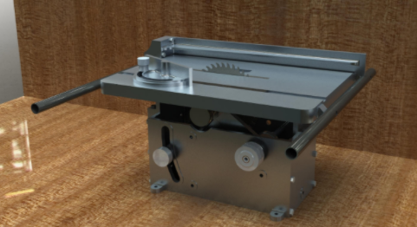
Figure 2. Descriptive Caption 2

