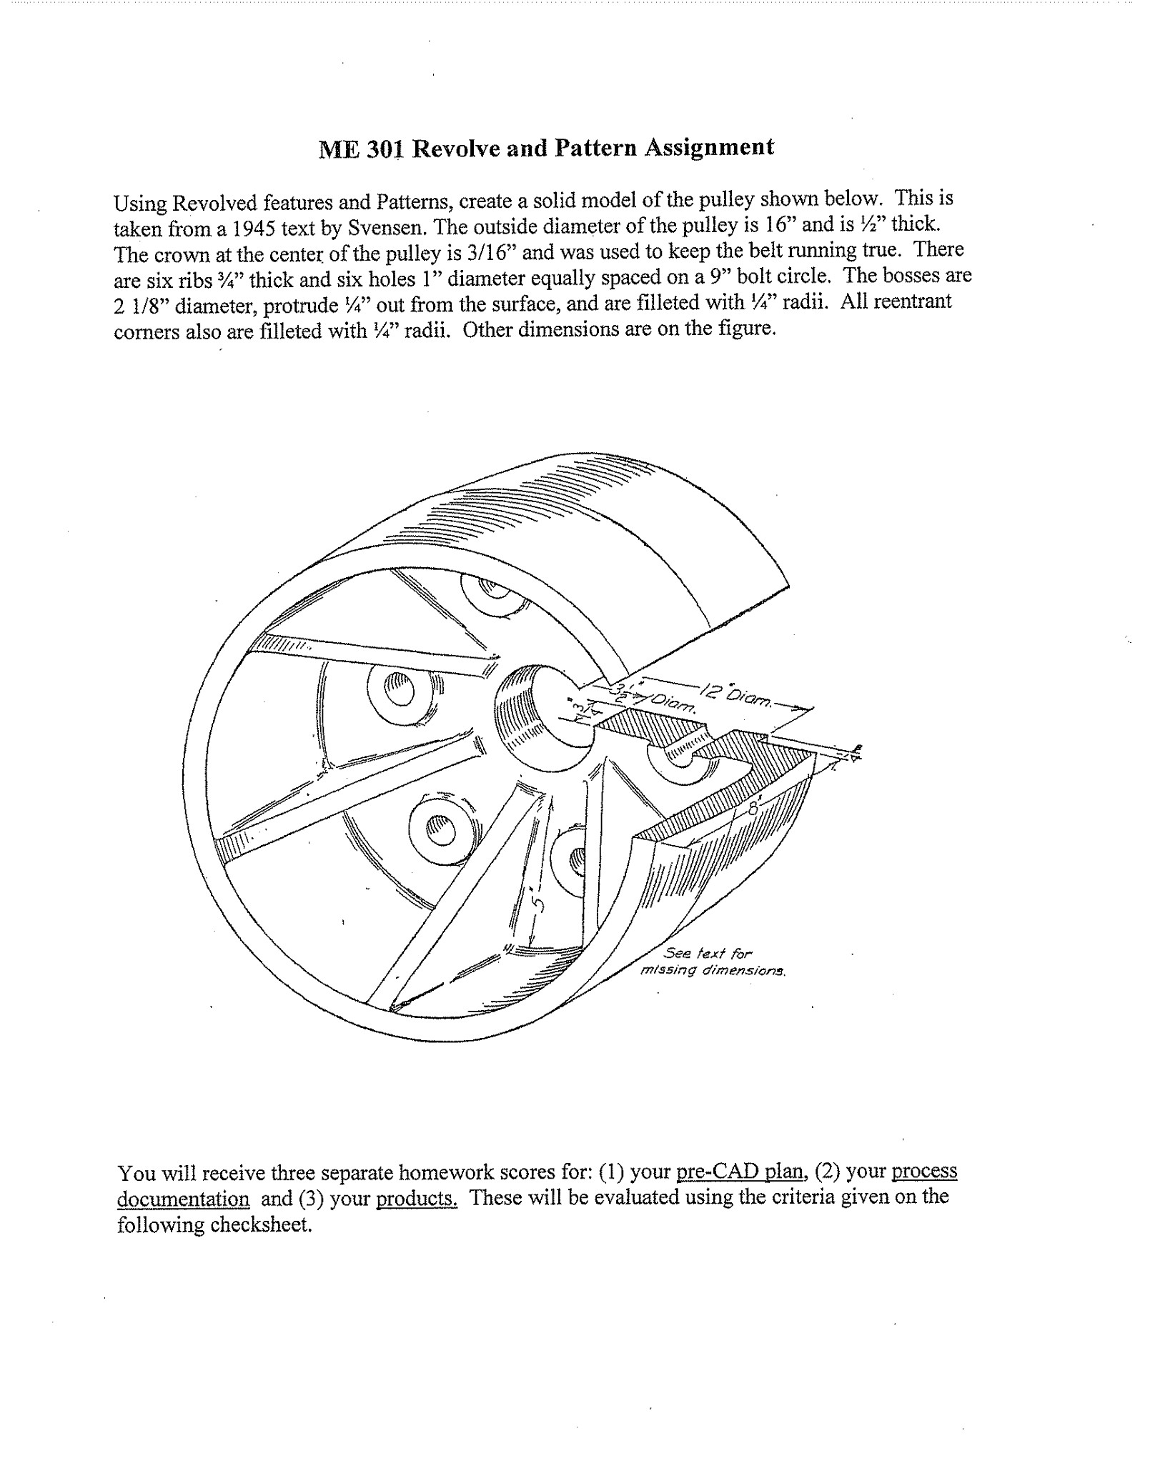

CHECKSHEET FOR REVOLVE & PATTERN FEATURES (HW9)
/15

NAME: _______________________ SECTION #: _____

Part A. Pre-CAD Plan
/5
___ Bulleted lists of feature creation steps and assumptions (i.e., size and/or location of non-specified features, etc.)
___ Identification of 2D sketches and thoughtful choice/selection of sketch planes
___ Identification of origin, x-y-z axes, and details about patterned features (feature, axis, and number of instances)
___ Identification of key relations and associated construction geometry
Above and Beyond (Exemplary)
___ Exceptional organization and neatness
___ Other:________________________________________________________________

Part B. Process Documentation
/5
___ Illustration & clear/concise discussion of sketches and pattern features (including relations, reference geometry, and order of implementation) (2 pts)
___ Annotated design tree showing fully-defined sketches
___ Lessons learned (at least three with substantive explanation)
Above and Beyond (Exemplary)
___ Exceptional organization and neatness
___ Other:________________________________________________________________

Part C. Final Products (based on finished model and design configurations)
/5
___ Accurate/attractive solid model
___ Illustration of global variables and equations used (at least 2 global variables and 2 equations)
___ Illustration of design table and each configuration (at least 3) (2 pts)
Above and Beyond (Exemplary)
___ Exceptional organization and neatness
___ Other:____________________________________________________ ____________
Point Deductions
___ No cover page (-1.5)
___ Not a .doc/.docx (-1.5)
___ Incorrect filename (-1.5)

PRE-CAD PLAN
Initial Assumptions:

Bulleted Feature Creation Steps (Ex: 1. Top plane Extrude Boss; 2. Right plane Revolve Cut; 3. Face Chamfer; 4. Pattern; 5. Mirror about new Plane 1):

More Details on Primary Features
From Step (#): ______
Sketch Plane: ________________________
3D Feature type: ________________________
Key Feature Details (dimensions/end conditions):
2D Sketch(es) from 1st primary feature

From Step (#): ______
Sketch Plane: ________________________
3D Feature type: ________________________
Key Feature Details (dimensions/end conditions):
2D Sketch(es) from 2nd primary feature

From Step (#): ______
Sketch Plane: ________________________
3D Feature type: ________________________
Key Feature Details (dimensions/end conditions):
2D Sketch(es) from 3rd primary feature

Potential Challenges:

PROCESS DOCUMENTATION

Illustration & clear/concise discussion of sketches and pattern features (including relations, reference geometry, and order of implementation) (2 pts)

Annotated design tree showing fully-defined sketches

Lessons learned (at least three with substantive explanation)

FINAL PRODUCTS

Accurate/attractive solid model

Illustration of global variables and equations used (at least 2 global variables and 2 equations)

Illustration of design table and each configuration (at least 3) (2 pts)

