Fall 2022 Part Mini Project Tips
“Kick Start Lever” Part 716 from the Motore MIB 851
(used in the Autofalciatrice 851 Italian Tractor assembly)
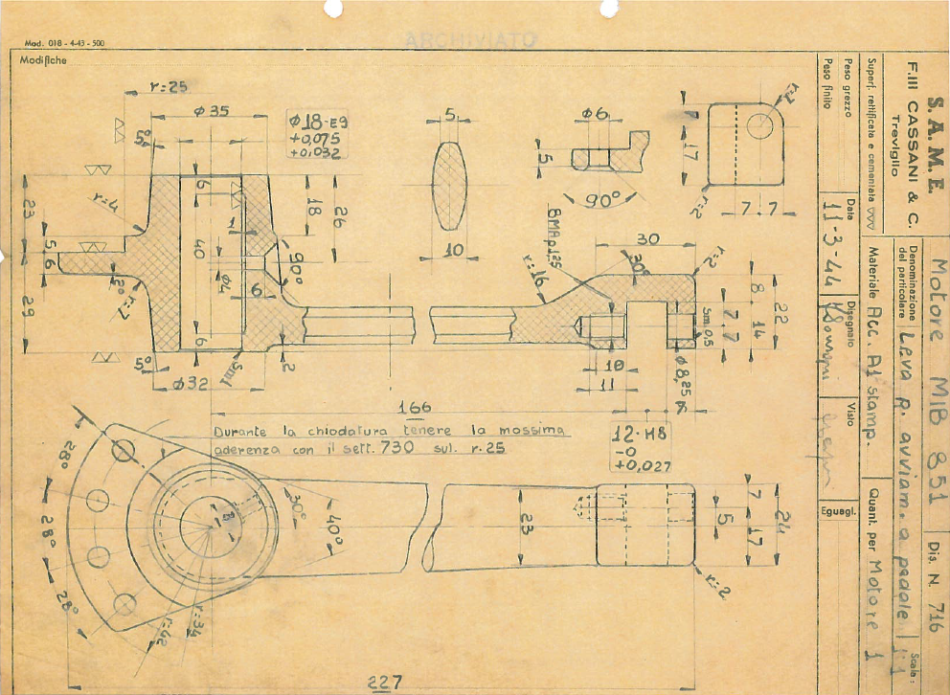
The drawing was hand made in 1946. As such, it may include errors, omissions, duplicate dimensions, or other inconsistencies that would prevent your model from being properly constrained (resulting in under or over constraint). This is where your engineering judgment comes in:
- Identify design intent (i.e., what was the purpose of the feature in question?).
- Determine which dimensions are of highest importance and should be maintained.
- Determine which dimensions can be altered.
- Make (and document) assumptions for dimensions that can’t be derived from those given.
- Keep track of your assumptions throughout.
Modeling Tips:
- Make sure you’re in the units you want to be in.
- The more complex your sketch, the more important it is to place sketch entities near where you want them as you’re sketching. Adding dimensions later to inaccurately sketched geometry can result in big changes to your sketch that might require deleting and recreating relations and/or sketch entities.
- Be mindful of auto-relations that Solidworks will add with each click (yellow icons prior to click).
- Consider use of feature fillets (rather than sketch fillets) to minimize clutter and complexity in the main sketch profile of your Revolve.
- Use SolidWorks dimension input box as a calculator to make your job easier.
  - You can enter “0.875-0.218” and let Solidworks do the math.
  - If you already have at least one equation in the model (so that Equations show up in your feature tree), you can enter “= 0.875-0.218” and have Solidworks compute the difference AND store the math as an equation.
  - You can be modeling in inches and enter “100mm” and Solidworks will convert to the active units selected in the model.
  - You can enter “0.25in + 6mm” and let Solidworks do the conversion and addition.
- Use the Measure tool from the Evaluate toolbar to double-check your part modeling accuracy.
- Elements not required for a perfect score (although may be considered for additional above and beyond points in the event that your effective use of views and clean dimensioning scheme weren’t as effective and clean as you hoped):
  - Dimensional tolerances provided on the drawing (e.g., H8, E9) – if you’re curious about any of them, feel free to ask, but you’re not required to add them into your model.
  - Surface finish callouts – not required.
  - Learning Italian (no points for this one, unfortunately) – see translations below.

Translations for the part mini project drawing
Italian English
Leva R. avviam. A pedale | Kick start lever?
Acc A1 | 303 Stainless Steel
Sm (Smussare) | Chamfer
Modifiche | Changes
8MA | Metric 8mm thread

