## Practice Problem

**28-1** Consider the following DIESEL CYCLE. Based on the array table data, determine:  
 a) Compression Ratio

b) Cut Off Ratio  
 c) Specific Compression Work

d) Specific Entropy Production (during Compression)

e) Specific Heat Addition (due to combustion)

f) Specific Entropy Production (during Heat Addition)

g) Specific Expansion Work  
 h) Specific Net Work (for the cycle)

i) Cycle Thermal Efficiency



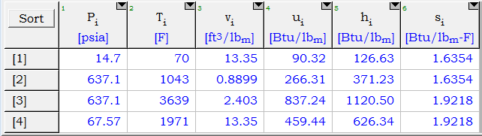

## Problem 2 and reading questions on next page

**28-2** A four-cylinder, four-stroke spark-ignition internal combustion engine is operating at 2800 rpm. The processes in each cylinder are assumed to follow an Otto Cycle with ambient conditions of 14.7 psia and 80°F, bottom dead center volume of 34 in3, a compression ratio of 10:1, and a maximum cycle pressure of 990 psia. Determine the following using EES (with ‘air_ha’) or with the air tables in your supplement:

1. the power developed by the four-cylinder engine (hp)
2. the thermal efficiency of the engine
3. the mean effective pressure (psia) of the engine cycle
4. Pv and Ts diagrams of of the engine cycle

## Preparatory Reading Questions

1. What are the similarities and differences between a Carnot refrigeration cycle and a vapor-compression cycle?
2. Sketch the arrangement of equipment in a typical vapor-compression refrigeration cycle.
3. Sketch the thermodynamic cycle followed by a vapor-compression cycle, labeling process endpoints to correspond to your diagram in question 2.
4. What are the properties of a good refrigeration fluid?

## Answers

1. For Diesel cycle
   1. CR ~ 15:1
   2. CO ~ 3:1
   3. w_compression ~ -175 Btu/lbm
   4. Δs_compression ~ 0 Btu/lbm-R (Ideal)
   5. q_combustion ~ 750 Btu/lbm
   6. Δs_combustion ~ 0.019 Btu/lbm-R (depending on boundary temperature used)
   7. w_expansion ~ 560 Btu/lbm
   8. w_cycle ~ 380 Btu/lbm
   9. Cycle efficiency ~ 51%

1. For gasoline engine
   1. Power ~ 50 hp
   2. Cycle efficiency ~ 55 %
   3. MEP ~ 120 psia