**PROBLEM 2.28**

**GIVEN**: An ideal gas that obeys the equation of state  undergoing the following thermodynamic processes that make up a thermodynamic cycle,

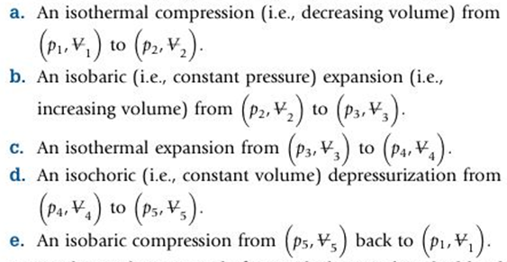

**FIND**: Sketch the cycle described above on  coordinates

**SOLUTION**: The isobaric processes are horizontal lines on the diagram and the isochoric lines are vertical. In order to understand the nature of the isothermal lines, the ideal gas law is rewritten as,





This indicates that the isotherm has a hyperbolic shape. For an isothermal compression, the pressure must increase whereas for an isothermal expansion, the pressure must decrease. Keeping this behavior in mind, the  diagram for this cycle is shown to the right.

**REFLECTION**:

* A thermodynamic *cycle* starts and ends at the exact same state.
* Some new terminology is introduced here that will be used throughout the course  
   **isobaric** = constant pressure  
   i**sothermal** = constant temperature  
   **isochoric** = constant volume
* Work associated with each process can be determined from the area under curve.
* Net work for the entire cycle is the enclosed area by the cycle.