ME 322 – Mechanical Engineering Thermodynamics (Exam 1)
Spring 2019
DO NOT TURN THIS COVER PAGE OR LOOK THROUGH THE EXAM QUESTIONS UNTIL YOU ARE INSTRUCTED TO DO SO.
Please read the following statement:
Article II, Section 1 of the University of Idaho Student Code of Conduct states,
Cheating on classroom or outside assignments, examinations, or tests is a violation of this code. Plagiarism, falsification of academic records, and the acquisition or use of test materials without faculty authorization are considered forms of academic dishonesty and, as such, are violations of this code. Because academic honesty and integrity are core values at a university, the faculty finds that even one incident of academic dishonesty seriously and critically endangers the essential operation of the university and may merit expulsion.
I have read and understand the above statement.

___________________________________________________ _____________
Signature Date

___________________________________________________
Printed Name (20 points)

EXAM INSTRUCTIONS – PLEASE READ THIS CAREFULLY
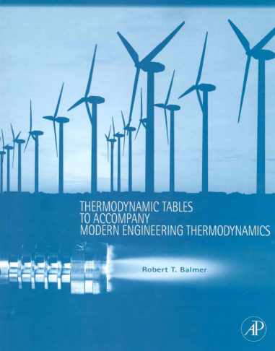
You will have 50 minutes to complete this exam. This time limit will be strictly enforced. This is a CLOSED TEXTBOOK exam. The only resources allowed are a hand-held calculator and the course textbook supplement cited below,
Balmer, R.T., “Thermodynamic Tables to Accompany Modern Engineering Thermodynamics, Elsevier Inc., Burlington, MA, 2011.
You may use the blank pages in the booklet to write anything you desire IN YOUR OWN HANDWRITING. Absolutely no cutting and pasting in the book is allowed, with the exception of a table that helps identify the phase of a state.
No computers, cell phones, iPhones, iPods, iPads, music players, or any other electronic equipment may be used during the exam with the exception of a hand-held calculator.
Show all of your work in the space provided on the exam. If more space is needed you should use the back of the exam.
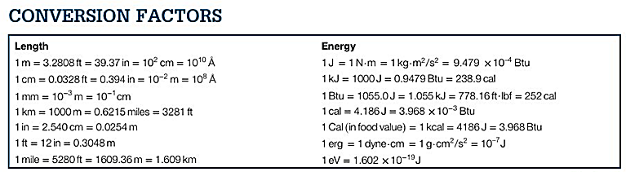
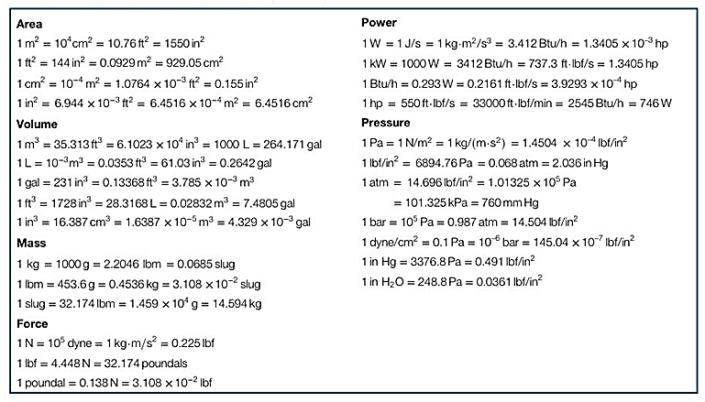
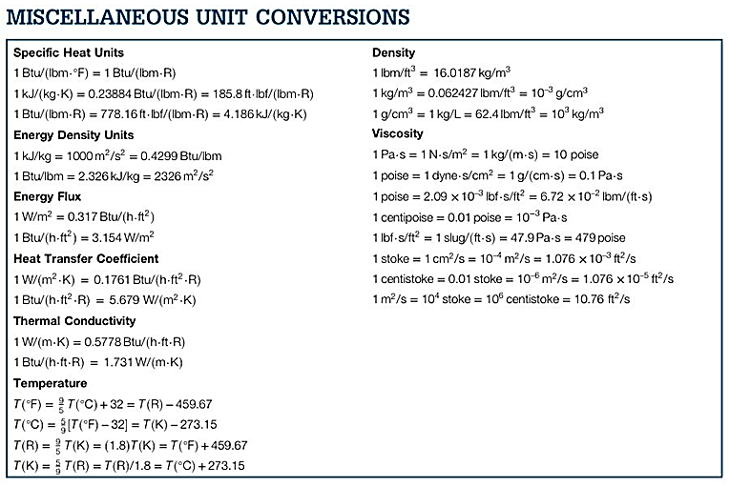
COMMON MOLAR MASSES: C=12; H=1; O=16; N=14
Part 1: Engineering Calculations – 80 Points
Note: When referencing values from tables, note the table and the values used as inputs to find your value (e.g. Table C.2a, with P=14.696 psia, and ν=.541 ft³/lbm)
Problem 1: (35 points) You have water that is initially a saturated liquid at 60 psia inside of a sealed container with an initial volume of 0.075 ft³. The water is then heated in an isobaric process until volume reaches 23.46 ft³. Use your tables (and some equations) to answer the following questions:
- What two independent, intensive properties do you know at State 1? (2 points)

- What is the temperature [°F] of the water at State 1? (3 points)

- What is the specific volume [ft³/lbm] at State 1? (3 points)

- What is the mass [lbm] of the water in the system? (5 points)

- How many moles [lbmol] of the water are in the system? (5 points)

- What is the specific volume [ft³/lbm] at State 2? (5 points)

- What two independent, intensive properties do you know at State 2? (2 points)

- What is the quality at State 2? (10 points)

Problem 2: (30 points) You have saturated water vapor (H₂O) at a temperature of 363.6 °F. It is in a rigid, sealed container. You then add heat to the water until it reaches a pressure of 300 psia. Use your supplemental tables to calculate/determine the following:
- Draw this process on the P-v diagram below, labeling the initial and the final states. (5 points)
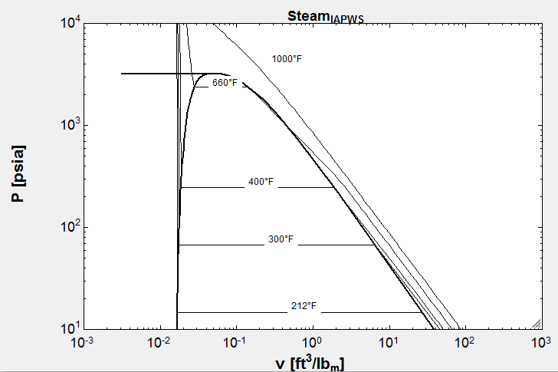
- What is the specific volume [ft³/lbm] at State 1? (5 points)

- Noticing that specific volume is constant between State 1 and State 2, use the superheated steam tables to determine the temperature [°F] at State 2 (to the nearest 100 °F). (10 points)

- Use First Law of Thermodynamics to calculate the amount of specific heat transfer (q, not Q) [Btu/lbm] required to move from State 1 to State 2. (10 points)
Problem 3: (15 points) You have a piston/cylinder filled with Nitrogen (N₂). The pressure is 50 psia, and it is at room temperature of 75 °F (~535 °R).
Note: The gas constant for Nitrogen (English units) is in Table C.13a
- Assuming it behaves like an ideal gas at these conditions, calculate the density [lbm/ft³] of the Nitrogen in the tank? (5 points)

- If the Nitrogen (modeled as an ideal gas) were compressed in a polytropic process where n = 1.4 from the initial state above to a final pressure of 135 psia and final temperature of 710 °R, calculate the specific work (work per mass) [ft*lbf/lbm] required for that compression. (10 points)

Part 2: Multiple Choice Bonus Questions –9 Bonus Points
3 points each. Each problem has just one answers. Make sure to show your work and/or justify your answer to score points
Problem 4: What is true if your solution window from your EES code contains the following message:
2 potential unit problems were detected.
a) your answers are still numerically correct
b) none of the numbers presented in the solution window can be trusted to be correct
c) clicking the “Check Units” box will fix your unit problem
d) no amount of time and/or consulting to debug the EES code will fix this problem

Problem 5:
What is the correct definition of quality within the two-phase region?
a) volume fraction of saturated vapor
b) volume fraction of saturated liquid
c) mass fraction of saturated liquid
d) mass fraction of saturated vapor

Problem 6:
There are no tables for compressed liquid ammonia in your supplement. If you wanted to approximate the specific volume of ammonia at 75 °F and 307.8 psia what would be a good number to use?
a) 0.02860 ft³/lbm
b) 0.9444 ft³/lbm
c) 0.02650 ft³/lbm
d) 2.0985 ft³/lbm

